PROJECT REPORT ON

**PERSONALISED WEBSITE FOR ALL IPL FANS (SAYIPL.COM)**

SUBMITTED BY

ANMOL TRIKHA

SAGAR SHAH

YASH THAKKER

T.Y.B.SC.IT

ACADEMIC YEAR

2012-2013



PROJECT GUIDE

PROFESSOR ARCHANA SHUKLA

**ACKNOWLEDGEMENT**

We wish to take this opportunity to express our sincere gratitude to all those who helped us in some way or the other in completion of our project.

We would like to thank our professors and project guide for their constant support, encouragement and guidance without which the successful completion of this project would be impossible.

We would like to specially thank Prof. Archana Shukla for always being supportive and inspiring us throughout the completion of our project.

It gives us great pleasure in expressing our sincere gratitude towards USHA PRAVIN GANDHI COLLEGE OF MANAGEMENT for providing us with valuable and necessary infrastructure to carry our project work.

This project has been completed under the guidance of Prof .Smruti Nanavaty, Prof. Swapnali Lotlikar, Prof. Archana Shukla, Prof. Mudassar Qureshi who provided us with their best support and help .

We would like to thank Dr. (Mrs). Geetha Mohan for constant support and guidance to our stream that has inspired us to conduct this project.

We would like to thank Jagdish Sir and Sandeep Sir for providing us to use the lab facilities.

Thank you for all your support.

Yours Sincerely,

Sagar Shah, Anmol Trikha and Yash Thakker

T.Y.Bsc(Information Technology)

**INDEX**

|  |  |  |  |
| --- | --- | --- | --- |
| **SR.NO** | | **TOPICS** | **PAGE NO** |
| 1 |  | **Scope** |  |
|  | 1.1 | Existing System |  |
|  | 1.2 | Proposed System |  |
|  | 1.3 | Objective of the Project |  |
|  | 1.4 | Fact Finding Techniques |  |
|  |  |  |  |
| 2 |  | **Technologies & Feasibility Study** |  |
|  | 2.1 | Technologies Used |  |
|  | 2.2 | Feasibility Study |  |
|  | 2.3 | System Specification |  |
|  |  |  |  |
| 3 |  | **System Analysis and Design** |  |
|  | 3.1 | System Analysis |  |
|  | 3.2 | System Design |  |
|  | 3.3 | Coding and Development |  |
|  | 3.4 | Testing |  |
|  | 3.5 | Implementation |  |
|  | 3.6 | Project Management |  |
|  |  |  |  |
| 4 |  | **Diagrams** |  |
|  | 4.1 | Gantt Chart |  |
|  | 4.2 | Use Case Diagram |  |
|  | 4.3 | Sequence Diagram |  |
|  | 4.4 | ER Diagrams |  |
|  |  |  |  |
| 5 |  | **Screenshots** |  |
| 6 |  | **Sample Code** |  |
| 7 |  | **Data Dictionary** |  |
| 8 |  | **Testing** |  |
| 9 |  | **Future Scope** |  |
| 10 |  | **Biblography** |  |

**INTRODUCTION**

***INTRODUCTION***

This website mainly targets Cricket enthusiasts. Cricket is the most common entity that has the huge fan following in every segment of the society whether Metros, towns and villages. The game is even popular among the people of all age group, gender, cast and creed. Money, Fame and Glory are three objects that drag individuals to become a part of this global religion. Cricket infrastructure in India is another big deal that pushes the phenomenon deeper. In every metro you can find at least one well equipped stadium. Delhi, Kolkata, Mumbai, Kanpur, Kochi, Chennai and Hyderabad etc are some of the prominent cities that are known for its well-knit cricket infrastructure and facilities for the players.

It is the “Indian Premier League “ that ignites the fire in various budding cricketers .This very innovative format of cricket not only offers monetary additions but is also very credible for offering opportunities to the emerging cricketing talents. Talents, even from some small towns or remote villages could show their zeal in this tournament.

**EXISTING SYSTEM**

***EXISTING SYSTEM***

Although there is a website that aims at targeting IPL fans providing them with various information and scores. Also the website is very easy to use and dynamic. In today’s modern era, a user wants everything at his service. Thus many users are not satisfied with the existing system. There are many flaws in the present system which we have rectified in our website.

**Drawbacks in the Existing System**

1. IPLT20.com does not allow the user to access information of only his favorite team – Thus it is not personalized.
2. It does not allow the user to create its own account and make his view personalized.
3. IPLt20.com does not provide the user with a shopping facility. A user has to go to some other online shopping website or visit the store physically. SAYIPL provides the user with a shopping cart where he can order merchandises of his favorite team and pay via credit/Debit card
4. If a User does not have access to television but has access to this internet he cannot watch the match on the IPL website . In SayIPL.com he can watch the match live without any hitches.
5. In future the registered user will be able to download the sayIPL application on iOS and Android platform.

**SYNOPSIS**

***SYNOPSIS***

This Website helps the user to attain information of his/her favorite IPL team, this making this website personalized. In this website, a user has to compulsorily register to create his/ her sayipl account . During registration he has to select his favorite team. After finishing the registration, when the user logs in he will only be able to see information about his favorite team that he has selected during registration. He will be able to access News items , browse through Fixtures , Access photographs , videos etc . The three very important modules of this product are

1. The Shopping Cart : The user can order his favorite items by browsing through items in the shopping cart and pay via Credit / Debit card .
2. Live Streaming Facility : The registered user can watch all IPL matches if he doesn’t have access to television .
3. User Guidance to Book Tickets : The website redirects the user to a specific website so that he can book tickets online .

**The Salient Features of our Project are:**

* Modularity
* User Friendliness
* Ease of Accessibility
* Ease of Customization( Administrator Only)
* *Easy & faster Data Accessibility*
* Secured payment methods
* Increased Productivity\ Efficiency
* The administrator can easily make changes in the modules whenever he wants .

**PROPOSED SYSTEM**

***Requirements of the Proposed System:-***

1. Website must be a solution to the Existing Manual System.
2. Completely web based.
3. It must provide user-friendly environment.
4. Should be least expensive.
5. No specialized technicians are required to operate the Website.

As the technology advances, the needs of the people also change . People now need everything at their service . The existing system has many drawbacks , we could eliminate these drawbacks by making a new Website with more advanced features and Personalization . To overcome the drawback of the existing system a new system is proposed by storing all User records in a Database.

The Website is developed in a user friendly way so that the user can easily understand it. Forms are designed so that the end-user can easily navigate through the entire system.

***Analysis of the Proposed System:-***

* To understand the needs of sayIPL.com:
  1. A user has to register in order to access all the features of the website .
  2. User has access to only specific information i.e. Information about his/her favorite team .
  3. Website can be used by any registered user who is familiar with the English language
  4. It must be as cheap as possible.
  5. The user data should be stored in database and the administrator has to have all the rights to access it .
* To perform the Market Survey:

1. Check the existence of such application elsewhere.
2. If it does exist then how to enhance that system.

According to our survey, there are no such commercial applications available in the market.

* To Understand how system can be implemented:
  1. As the users information was intended to be stored in user friendly database storage for record keeping, we decided to use SQL and PHP as a backend and HTML 5 as frontend.
  2. The need of a new user is free sign up and then has all access to information and features of the website .

***Benefits of the Proposed System***

1. Firstly, it would enable the user to register and specify his favorite team.
2. Thus when the user signs in, he only see’s the information relating to his favorite team .
3. The Website enables the user to buy merchandises of his favorite team and pay via his credit card / Debit card
4. The proposed system gives the administrator a login facility providing authentication.
5. Allows the user to view matches online i.e. Live Stream all the matches anytime, anywhere via the internet.

**OBJECTIVES OF THE PROPOSED SYSTEM**

The main objectives of the Proposed System are:

1. **USER LOGIN** :

The user has to login in order to view the website.

1. **REGISTRATION OPTION IS PROVIDED** –

All the users who want to access the services of this website have to compulsorily register and select their favorite team.

1. **ADMIN LOGIN** :

The administrator has to login in order to edit/update and make any changes he requires in the website.

1. **INTEGRATION WITH PAYPAL** :

The customers are provided with a payment gateway wherein they can pay their money then and there.

1. **AUTOMATIC BILL GENERATION** :

The customers while selecting there products would see their bill before checking out . This would help them know if they are shopping within their budget or no.

1. **SECURITY** :

Security is taken care of and customers do not need to worry the integrity of sensitive data.

1. **USER FRIENDLY** :

This website is very user friendly. It provides a very user friendly interface. It is also very interactive and customers will find it very easy to shop.

1. **SHOPPING CART** :

Shopping cart is provided for selling multiple products to same customers.

1. **LIVE STREAMING** :

Registered Users can now stream the matches online using this website.

1. **PERSONALISATION** :

This is a very important aspect of our website. A registered User selects his favourite team when he signs up. On signing in, he is provided with the information of only his favourite team.

1. **TICKET BOOKING REDIRECTION** :

Registered Users are redirected to a website where they can book tickets easily.

**Fact Finding Techniques**

Requirement analysis is the important part of preliminary investigation, which is the base of total system. The main objective of requirement analysis is to study existing system and to suggest the possible changes to be done to make the new system efficient and cost effective. Following fast finding techniques are used while requirement analysis:-

* *Interview and Questionnaire*
* *Record view*
* **Interview and Questionnaire** :-

*Interview and Questionnaire are* the step by step procedures by which correct and appropriate information can be gathered.

Following are the question’s that we asked IPL fans .

* + Where do you buy your Favorite teams jersey from ?
  + How do you pay for things ordered online ?
  + Do get all your teams information in IPLT20.com?
  + Can you watch IPL matches live on IPLT20.com?
  + Can you shop on IPL’s official website ?
  + Can you be redirected for buying tickets of your favorite team?
* **Record view:**

There are absolutely no records maintained by the existing system about users who many to make a team as a favorite.

**Technologies Used**

***HTML 5:-***

***Why HTML 5?***

**HTML5** is a markup language for structuring and presenting content for the World Wide Web and a core technology of the Internet. HTML5 is intended to subsume not only HTML 4, but XHTML 1 and DOM Level 2 HTML as well.

In particular, HTML5 adds many new syntactic features. These include the new <video>,<audio> and <canvas> elements, as well as the integration of scalable vector graphics (SVG) content (that replaces the uses of generic <object> tags) and MathML for mathematical formulas. These features are designed to make it easy to include and handle multimedia and graphical content on the web without having to resort to proprietary plugin and APIs. Other new elements, such as <section>, <article>, <header> and<nav>, are designed to enrich the semantic content of documents.

### *FEATURES:*

### Markup

HTML5 introduces elements and attributes that reflect typical usage on modern websites. Some of them are semantic replacements for common uses of generic block (<div>) and inline (<span>) elements, for example <nav> (website navigation block), <footer>(usually referring to bottom of web page or to last lines of HTML code), or <audio> and <video> instead of <object>.Some deprecated elements from HTML 4.01 have been dropped, including purely presentational elements such as <font> and<center>, whose effects have long been superseded by the much more powerful Cascading Style Sheets. There is also a renewed emphasis on the importance of DOM scripting (e.g., JavaScript) in Web behavior.

### *New APIs*

In addition to specifying markup, HTML5 specifies scripting application programming interfaces (APIs) that can be used withJavaScript .  Existing document object model (DOM) interfaces are extended and *de facto* features documented. There are also new APIs, such as:.

* The canvas element for immediate mode 2D drawing. See Canvas 2D API Specification 1.0 specification
* Timed media playback
* Offline Web Applications
* Document editing
* Drag-and-drop
* Cross-document messaging
* Browser history management
* MIME type and protocol handler registration
* Microdata
* Web Storage, a key-value pair storage framework that provides behaviour similar to cookies but with larger storage capacity and improved API.

Not all of the above technologies are included in the W3C HTML5 specification, though they are in the WHATWG HTML specification.[[41]](http://en.wikipedia.org/wiki/HTML5#cite_note-41) Some related technologies, which are not part of either the W3C HTML5 or the WHATWG HTML specification, are as follows. The W3C publishes specifications for these separately:

* Geolocation
* Web SQL Database, a local SQL Database (no longer maintained).
* The Indexed Database API, an indexed hierarchical key-value store (formerly WebSimpleDB).
* HTML5 File API, handles file uploads and file manipulation.
* Directories and System, an API intended to satisfy client-side-storage use cases not well served by databases
* File Writer, an API for writing to files from web applications.
* Web Audio API, a high-level JavaScript API for processing and synthesizing audio in web applications.

HTML5 alone cannot provide animation within web pages. Either JavaScript or CSS3 is necessary for animating HTML elements. Animation is also possible using JavaScript and HTML 4, and within SVG elements through SMIL, although browser support of the latter remains uneven as of 2011.

### *Error handling*

An HTML5 (text/html) browser will be flexible in handling incorrect syntax. HTML5 is designed so that old browsers can safely ignore new HTML5 constructs. In contrast to HTML 4.01, the HTML5 specification gives detailed rules for lexing and parsing, with the intent that different compliant browsers will produce the same result in the case of incorrect syntax.Although HTML5 now defines a consistent behavior for "tag soup" documents, those documents are not regarded as conforming to the HTML5 standard.[[54]](http://en.wikipedia.org/wiki/HTML5#cite_note-whatfaq-54)

### *Popularity*

According to a report released on 30 September 2011, 34 of the world's top 100 Web sites were using HTML5 – the adoption led by search engines and social networks.

***WHY PHP?***

### The Top Three Reasons to use PHP:

You may be considering using PHP on your website. Here are some great reasons to start!

**1.) Works Great with HTML** - If you already have a website and are familiar with HTML, making the step to PHP is easy. If fact, PHP and HTML are interchangeable within the page! While PHP might add some new features to your site, its basic appearance is still all created with HTML.

**2.) Interactive Features** - PHP allows you to interact with your visitors in ways HTML alone can't. This can mean simple things like e-mail forms, or more elaborate things like shopping carts that save your past orders and recommend similar products. It can also mean social things like interactive forums and private messaging systems.

**3.) Easy to Learn** - PHP is a lot easier to get started with than you might think. By learning just a few simple functions, you are able to do a lot of things with your website. And once you know the basics, there are a wealth of scripts available on the internet that you only need to tweak a little to fit your needs.

**Why Wamp ?**

**WAMP**s are packages of independently created programs installed on computers that use a Microsoft Windows operating system.

WAMP is an acronym formed from the initials of the operating system Microsoft Windows and the principal components of the package: Apache, MySQL and one of PHP, Perl or Python. Apache is a web server. MySQL is an open-source database. PHP, Perl and Python are scripting languages that can manipulate information held in a database and generate web pages dynamically each time content is requested by a browser. Other programs may also be included in a package, such as phpMyAdmin which provides a graphical user interface for the MySQL database manager.

**Feasibility Study**

For the implementation of the proposed system many aspects and factors are considered in designing so that the new system can easily takeover the existing system .any system can be judged on its feasibility factors, different feasibility factors are:

1. Technical Feasibility:-

Technical aspects were considered while the feasibility study was conducted. Since the organization has licensed copy of all the software’s required for the system as well as necessary hardware to meet the requirement of the new system. It can be concluded that the system is technically feasible.

1. Operational Feasibility:-

The users of the system will mainly be a non technical computer literate who will be very familiar with the working of the computer and will have the skills required to use the system.

No training is required for a new user as the website itself is user-friendly and easily accessible. Hence, we can conclude that the system is operationally feasible.

1. Economic Feasibility:-

A economic feasibility was carried out to know the economic viability of the project in terms of the amount of investment in the project and the output expected. The study includes the cost involved at the time of development of the project as well as the future cost in terms of maintenance of software and other miscellaneous expenditure.

The proposed hardware and software are easily available at affordable cost. Cost of developing the software is very little.

Start up Cost:

* Cost of training.
* Cost of preparation of manuals and other documents.

Operational Cost:

* Cost of Installation & Maintenance of software’s.
* Cost of stationery for preparing documents.
* Cost of operating staff.

On the basis of cost benefit analysis the study concluded that the project is Economically Feasible.

1. Social Feasibility

As the new system is very user-friendly, mostly all the users are satisfied and happy with this system. Thus, this system is socially feasible.

***Result of Feasibility Study***

On all the Four levels i.e. Technical, Operational, Economical, Social level, the proposed system is feasible. System provides more benefits when compared with the manual system on the basis of cost incurred.

# System Specification

# *Hardware Requirements:-*

1. Processor : Pentium 4 Or higher.
2. Memory : 64MB RAM or higher.
3. Space : Minimum 10MB of Hard Disk space.
4. Peripherals : Keyboard, Mouse, Printer,Speakers etc…

# *Software Requirements :-*

# Windows XP or higher

* MSSQL Database

***Languages Used:-***

1. HTML 5
2. mySQL
3. PHP V5.3.2
4. JQuery

***SYSTEM ANALYSIS AND DESIGN :***

* + *SYSTEM ANALYSIS*
  + *DESIGN*
  + *CODING AND DEVELOPMENT STAGE*
  + *TESTING*
  + *IMPLEMENTATION*

**SYSTEM ANALYSIS**

System Analysis is a step in website development which includes analysis or identification of various requirements of the system. It helps the developers with some key features or hints which might help the programmers to develop the application easily and more efficiently.

System Analysis phase is also useful to determine exactly what the system requires and what functionalities are expected from the end system. It can be done only after the components of the system are defined, this, there should be a set of guidelines or outputs that each component offers.

The requirement gathering process is intensified and focused especially on software. To understand the nature of the programs to be built, the software engineer must understand the information domain for the software as well as required functional behavior, performance, and interface. Requirements for both the system and the software are documented and reviewed with the customer.

**DESIGN**

The design stage in website development includes designing the system in such a manner that it meets the expectation of the end user.

Website design is actually a multi step process that focuses on four distinct attributes of a program:

1. Interface Representation
2. Required Information
3. Database Structure
4. Procedural Detail

The design process translates the requirements into representation of the software that can accessed for quality before coding begins.

Designing is a very important phase, during design progressive refinements of database structure, interface, and procedural details are components are develop, reviewed, and documented.

A user interface in the system is also one of the most important aspects as the user interacts with the system through the interface. The user interface in the system is also one of the most important aspects as the user interacts with the system through the interface.

**CODING AND DEVELOPMENT STAGE**

The Analysis specification and the design stage is followed by the heart of the system development process, the coding phase is one which is responsible for whatever output the system gives or is supposed to give.

The design must be translated into machine readable form. The code generation step performs this task. If the design is performed in a detailed manner, the code generation can be accomplished mechanically.

In projects, which are related to information technology, it is virtually impossible to develop a system without pieces of code. The computer cannot interpret the user level language. Hence coding or developing stage plays a very important role in the development lifecycle.

Thus coding stage basically involves all the technicalities related to the system and those required for various events to occur in the system as per requirements.

**TESTING**

Once the code has been generated, program testing begins. Testing process focuses on the logical internals of the system ensuring that all th statements are been tested and all functional externals, that is, uncovering errors and ensuring that the defined input will produce the actual results that agree with the required results.

The testing phase enables the user as well as the developer to analyse what improvements could be made to the system so that the user is satisfied. Also in this phase, sometimes the systems implemented in the organization are give to the user for demonstration so that the user is well versed with the system till the time the system is actually implemented.

Before going live, the website is tested for all validations. Testing involves making the prototype of the system being developed.

Testing presents an interesting anomaly for developers. During earlier engineering activities, the developer attempts to build a word application from an abstract concept to a tangible product. Now come “testing”. The developer creates a series of test cases that are intended to demolish the system that has been built.

Testing requires that the developer discards pre-conceived notations of the correctness of the system just developed. If testing is conducted successfully, it will uncover errors of the system. Testing also demonstrates that the system function appears to be working according to specification, that behavior and performance requirements appear to have been met. In addition, data collected as testing is conducted to provide good indication of system reliability and some indication system quality as a whole.

**IMPLEMENTATION**

The testing stage is followed by implementation in which the actual system is implemented and can be done by effective and efficient passage through the above stages along with the user satisfaction.

Implementation in context of a website would mean hosting the website on the internet or in other words going live. Server space needs to be bought by the client for hosting the website.

Once the server space is bought, the website can be implemented. Hereafter, the website would be visible to public and can be accessed by any person on the internet.

**Project Management**

Project Management is the process of scoping, planning, organizing and controlling the development of an acceptable system at a minimum cost and within a specified time frame.

***Choosing a Model***

As most business solutions and the activities are closely related, usually inseparable and have complex relationship among them .Thus to reduce risk associated with shortcuts and mistakes, Software Engineering branch has been developed. Certain steps have to be followed in the development of a system .These steps are known as Models. Various popular models for developing the project are SDLC, RAD, SPIRAL, etc.

Among these we have chosen SDLC (System Development Life Cycle) because it is the most popular as compared to other models and more flexible for development of any kind of application. The various phases of SDLC are given below:

1. Preliminary Investigation
2. Problem Analysis
3. Requirement Analysis
4. Decision Phase
5. Design Phase
6. Construction Phase
7. Installation Phase
8. Maintenance

***Various Stages of System Development Life Cycle***

* **PRELIMINARY INVESTIGATION:-**

1. Scope of the project.
2. List problems and opportunities.
3. Estimate the approximate cost of the project.
4. Plan the project.
5. Submit the project and plan.

* **PROBLEM ANALYSIS:-**

1. Analyze the problems.
2. Analyze the way it is utilized in a business.
3. Establish system improvement objectives.
4. Present findings and recommendations.

* **REQUIREMENT ANALYSIS:-**

1. Define requirements.
2. Analyze functional requirements.
3. Trace and complete requirements.
4. Prioritize requirements.

* **DECISION ANALYSIS:-**

1. Identify candidate solutions.
2. Analyze candidate solutions.
3. Compare candidate system.
4. Recommend a solution.

* **DESIGN PAHSE:-**

1. Design the application architecture (user interactive forms).
2. Design the system database.
3. Design the system interface.
4. Package design.

* **CONSTRUCTION PHASE:-**

1) Build and test database

1. Install and test new software packages.
2. Write and test new programs.

* **INSTALLATION PHASE:-**

1. Conduct system test.
2. Install database.
3. Train users.
4. Change to new system.

* **MAINTENANCE PHASE:-**
  + Validate the problem.
  + Study and debug the program.
  + Test the program.
  + System recovery during hardware and software failures.
  + System improvements ideas.

**DIAGRAMS**

1. GANTT CHART
2. USE CASE DIAGRAM
3. SEQUENCE DIAGRAM
4. ER DIAGRAM

**GANTT CHART**

A Gantt chart is a type of bar chart that illustrates project schedule. Gantt illustrates the start and finish dates of the terminal elements and summary elements of a project.

Terminal elements and summary elements comprise of work breakdown structure of the project. Some Gantt charts also show the dependency relationship among activities.

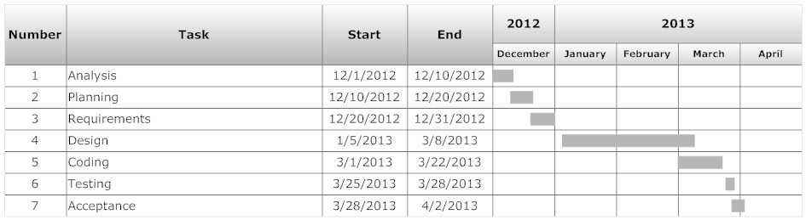

**USE CASE DIAGRAMS**

A use case defines goal oriented set of interactions between external actor and the system under consideration. A use case is a list of steps typically defined in interaction between a role and a system to achieve a goal. Use cases are used during the analysis phase of a project to identify a partitioned system functionally.

Actors are parties outside the system that interact with the system. An actor maybe a class of users, roles users can play or other systems. A use case is initiated by a user with a particular goal in mind and complete successfully when that goal is satisfied. It describes a sequence of interactions between actors and systems necessary to deliver the service that satisfies the goal.

LIMITATIONS:

1. Use cases are not well suited to capturing non interaction based requirements of a system.
2. As there is no fully standard definition of use case, each project must form its own interpretation.
3. Some use case relationships such as extends, are ambiguous in interpretation and can be difficult for stakeholders to understand.
4. Use case developers often find it difficult to determine the level of user interface dependency to incorporate in use case.
5. Use case can be over emphasized issues such as driving system design to literally from use cases and using use cases to the exclusion of other potentially valuable requirements analysis techniques.

USE CASE FOR ADMINISTRATOR

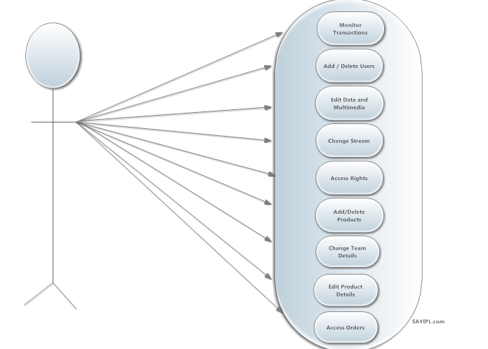

USE CASE FOR CUSTOMER

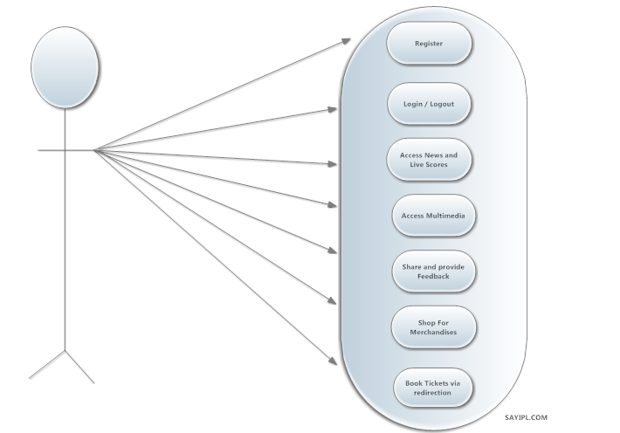

USE CASE FOR CUSTOMER (SHOPPING)

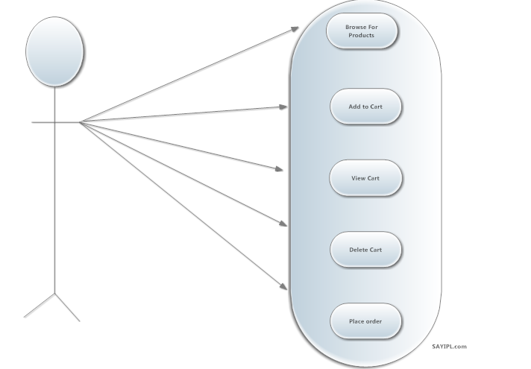

**SEQUENCE DIAGRAMS**

The sequence diagram is a unified modeling language (UML), is a kind of interaction diagram that shows how processes operate with one another and with what order. UML sequence diagrams are used to show how objects interact in a given situation. An important characteristic of a sequence diagram that time passes from top to bottom: The interaction starts near the top of the diagram and ends at the bottom.

It is a construct of a message sequence chart. A sequence diagram shows object interactions arranged in time sequence. It depicts the objects and classes involved in the scenario and the sequence of messages exchange between objects needed to carry out the functionality of the scenario. Sequence diagram are typically associated with use case realizations in logical view of the system under development.

UML sequence diagrams model the flow of logic within your system in a visual manner, enabling you both to document and validate your logic, and are commonly used for both analysis and design purposes. Sequence diagrams are most popular in UML artifacts for dynamic modeling, which focuses on identifying the behavior within your system.

Sequence diagrams are sometimes called event diagrams, event scenarios and timing diagrams. One of the primary usages of sequence diagrams is in the transition from requirements expressed as use cases to the next and more formal level of refinement. Use cases are refined into one or more sequence diagrams.

SEQUENCE DIAGRAM FOR USER ON REGISTRATION

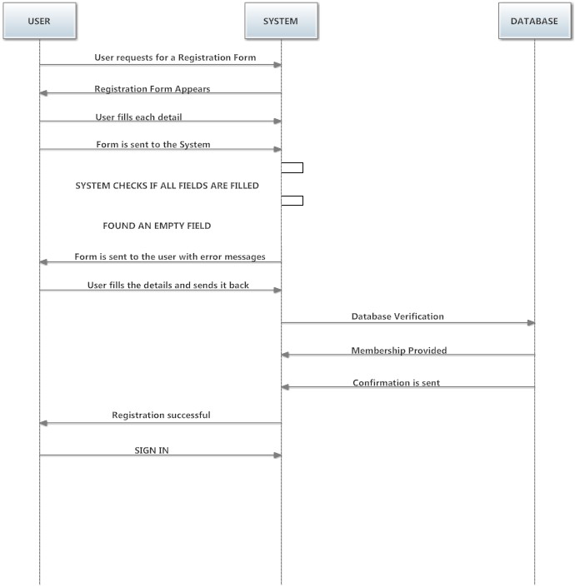

SEQUENCE DIAGRAM FOR USER LOGIN

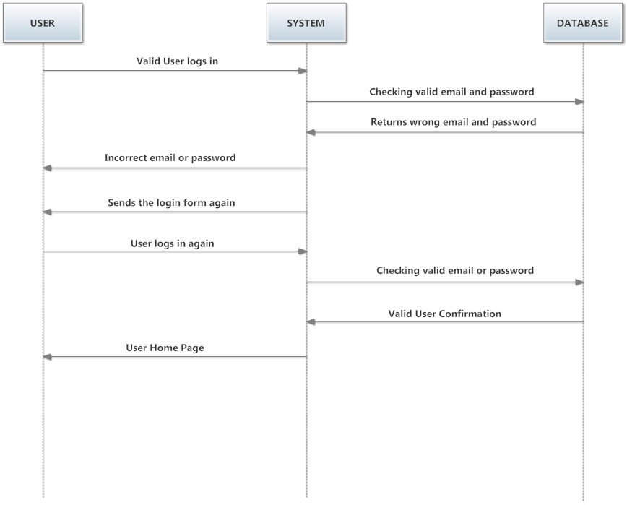

SEQUENCE DIAGRAM FOR USER (SHOPPING CART)

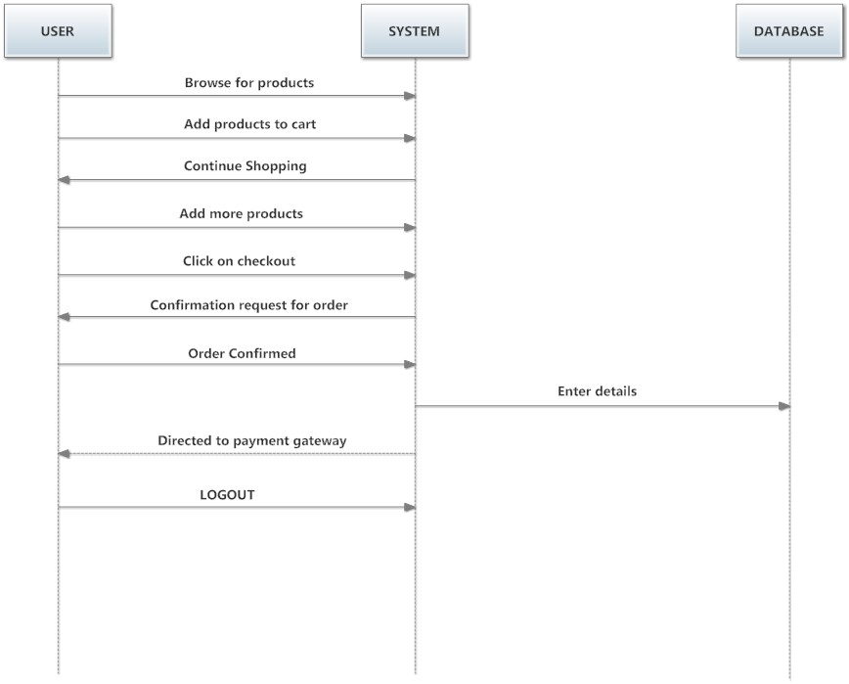

SEQUENCE DIAGRAM FOR ADMINISTRATOR (GENERAL)

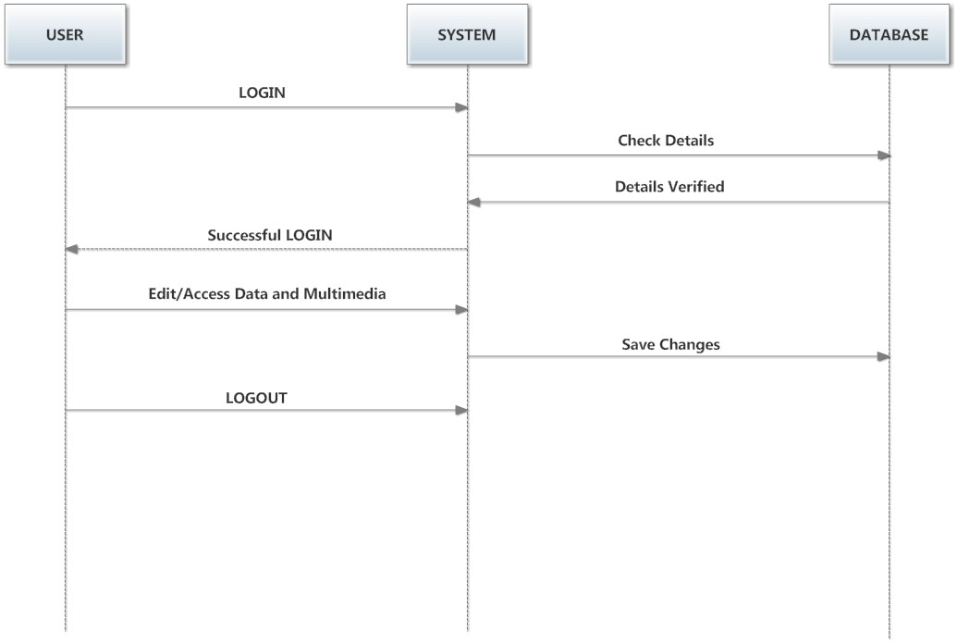

SEQUENCE DIAGRAM FOR ADMINISTRATOR (SHOPPING CART)

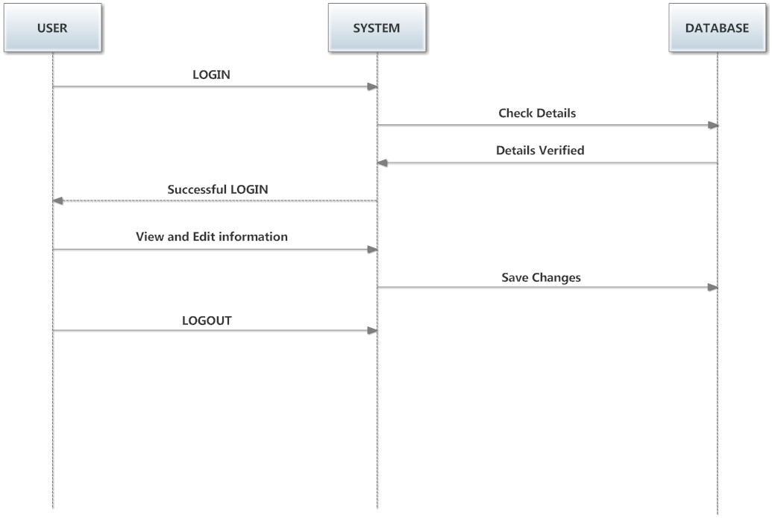

**E-R DIAGRAM**

#### Data models are tools used in analysis to describe the data requirements and assumptions in the system from a top-down perspective. They also set the stage for the design of databases later on in the SDLC.

#### There are three basic elements in ER models:

#### Entities are the "things" about which we seek information.

#### Attributes are the data we collect about the entities.

#### Relationships provide the structure needed to draw information from multiple entities.

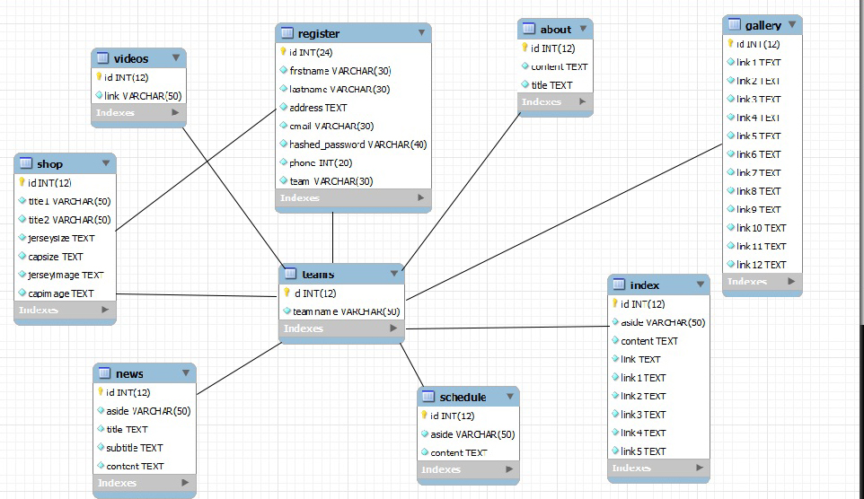

***SCREENSHOTS***

***Home Page***

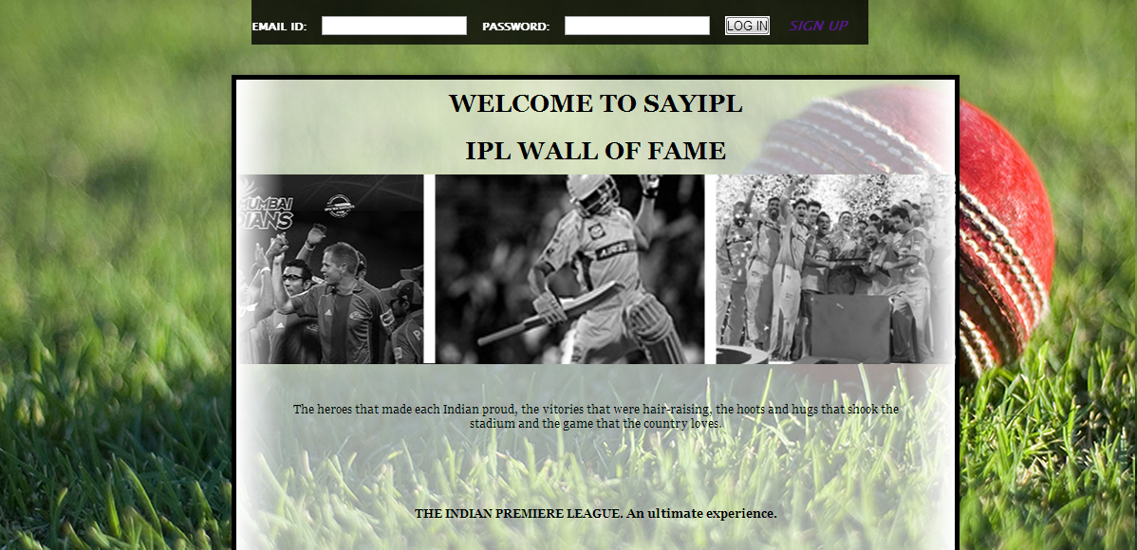

**SignUp Page**

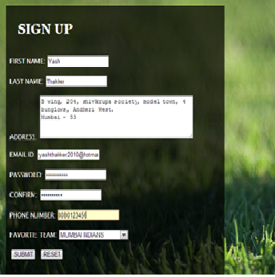

**UserHomepage**

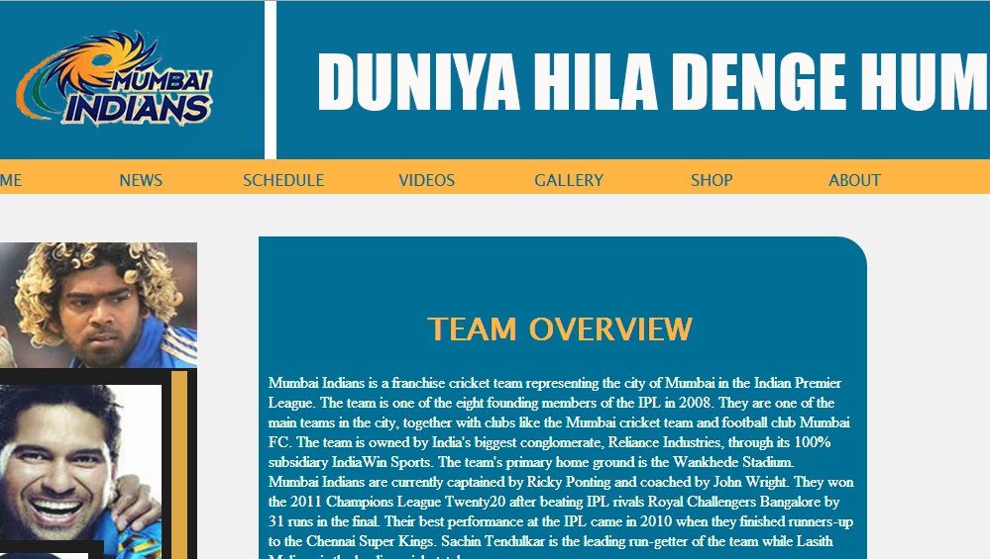

**Gallery**

**Image SlideShow**

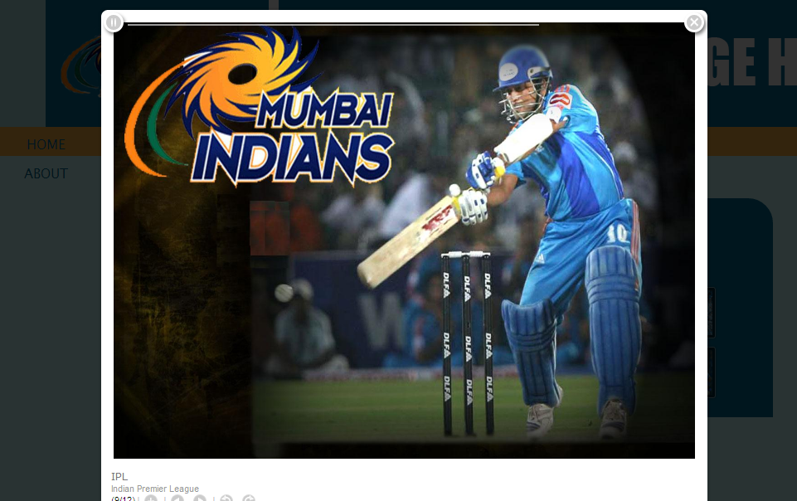

**LiveStream(Videos)**



**Shopping**

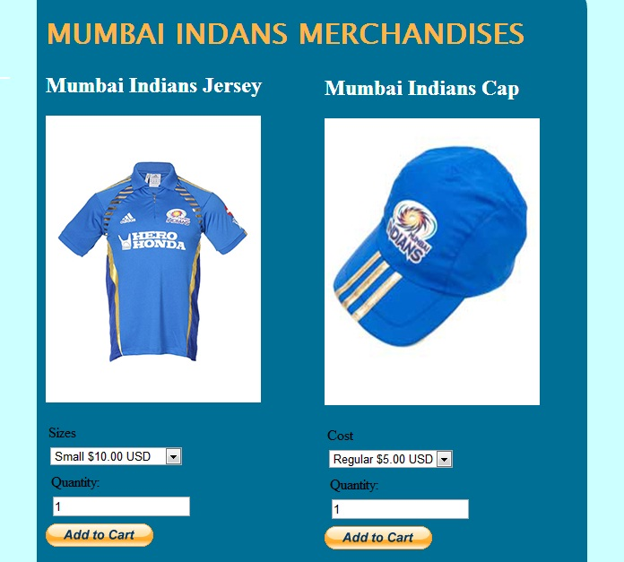

**Order Information**

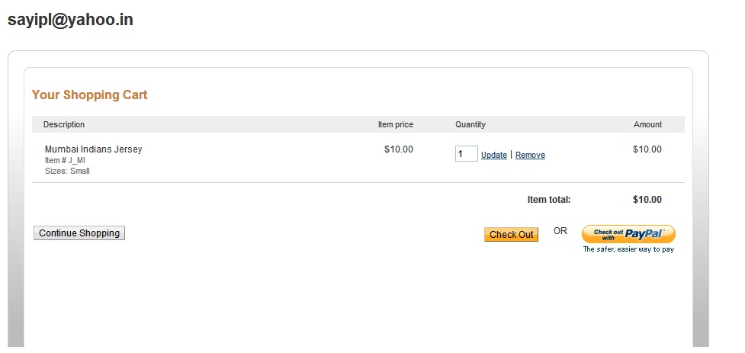

**Order Summary**

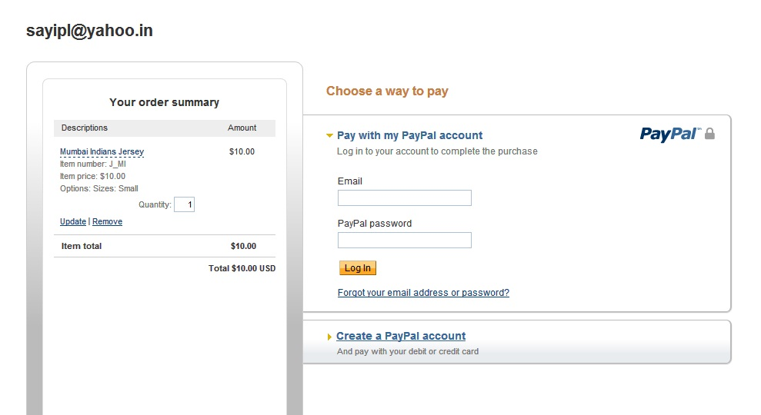

**ADMINISTRATOR SCREENSHOTS**

**Admin HomePage**

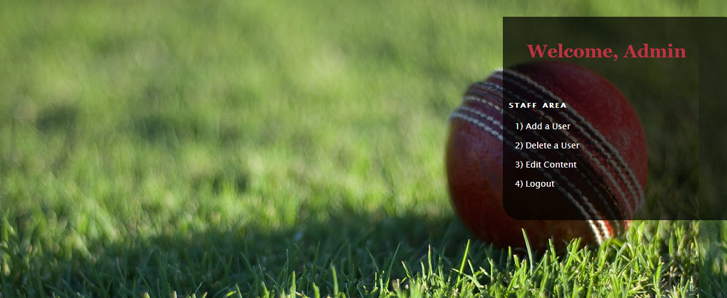

**Admin(Add a user)**

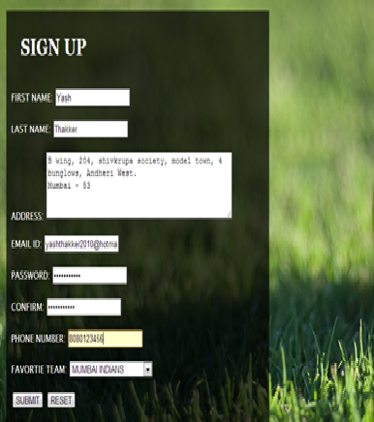

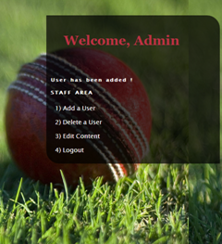

**Admin(Delete a User)**

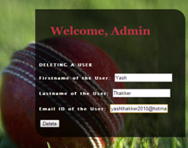

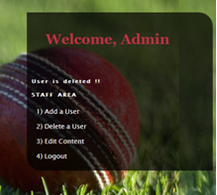

**Admin(Edit Content Page)**

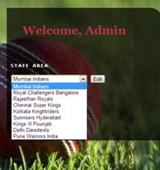

**Edit Content( Schedule)**

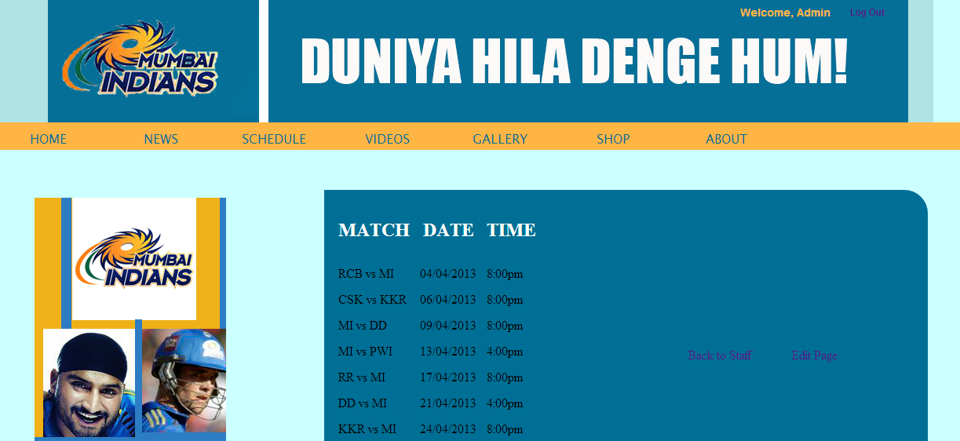

**Edit Content (Update Schedule)**

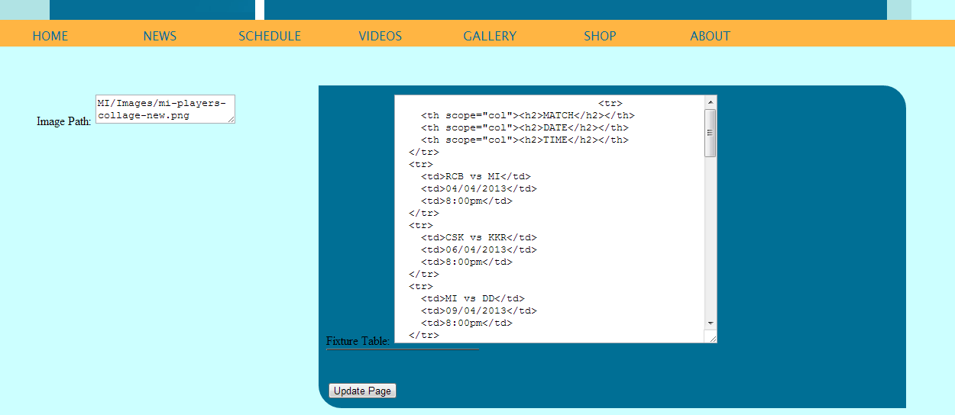

**Administrator(Photostream)**

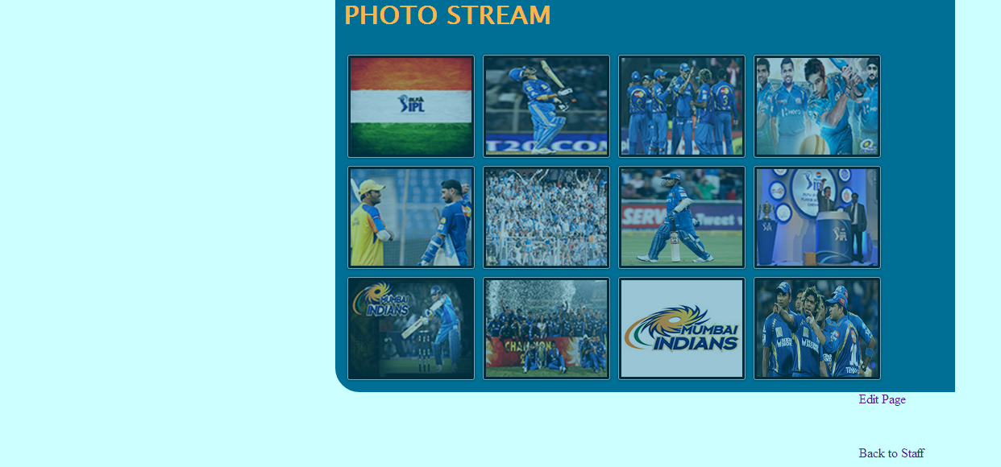

**Edit Photostream**

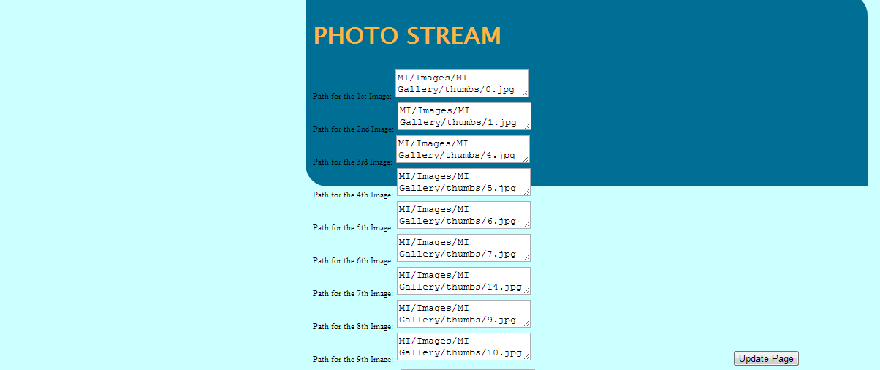

**Data Dictionary**

* Table Name : Register
  + - * Description : This table stores all the information of the user.
      * Use : Use for adding and retrieval of user information.
      * Programs using it : Mysignin.php , Mysignup.php
* Table Name : Teams
  + - * Description : This table stores all the names of the IPL teams.
      * Use : Use for retrieval of IPL team names.
      * Programs using it : EditContent.php , EditContentCode.php
* Table Name : (About , Gallery , Index,News , Schedule , Shop,Videos)
  + - * Description : This table stores all the information and links that are displayed to the user on each of the webpages on this website.
      * Use : Use for adding and retrieval of information that can be seen by the user.
      * Programs using it : index.php,gallery.php,about.php, videos.php,shop.php and so on

***CODING***

**Connection.php**

<?php

$mysql_hostname = "localhost";

$mysql_user = "root";

$mysql_password = "";

$mysql_database = "sayipl1";

$prefix = "";

$bd = mysql_connect($mysql_hostname, $mysql_user, $mysql_password) or die("Could not connect database");

mysql_select_db($mysql_database, $bd) or die("Could not select database");

?>

**Mysqlprep.php**

<?php

function mysql_prepare($value)

{

$magic_quotes_active= get_magic_quotes_gpc();

$new_enough_php= function_exists("mysql_real_escape_string"); //i.e PHP >= v4.3.0

if($new_enough_php)

{

// PHP v4.3.0 or higheer

// undo any magic quote effects so mysql_real_escape_string can do the work

if(magic_quotes_active)

{

$value= stripslashes($value);

}

$value= mysql_real_escape_string($value);

}

else

{

//before PHP v4.3.0

// if magic quotes aren't already on then add slashes manually

if( !$magic_quotes_active )

{

$value= addslashes($value);

} // if magic quotes are active, then the slashes already exist

}

return $value;

}

?>

**Logout.css**

@charset "utf-8";

#uname {

position:absolute;

left:954px;

top:-2px;

width:20%;

height:25px;

z-index:10;

font-family: Arial, Helvetica, sans-serif;

font-size: 14px;

color: rgba(255,181,67,1);

font-style: normal;

font-weight: bolder;

}

#logout {

position:absolute;

left:1094px;

top:12px;

width:15%;

height:29px;

z-index:12;

font-family: Arial, Helvetica, sans-serif;

font-size: 12px;

color: rgba(255,181,67,1);

font-style: italic;

font-weight: bolder;

}

**Mysignin.php**

<!DOCTYPE html>

<html>

<head>

<meta charset='UTF-8'>

<title>WELCOME TO sayipl.com</title>

<link rel='stylesheet' href='css/style.css'>

<style>

#tech-slideshow {

height: 200px;

position: relative;

overflow: hidden;

}

#tech-slideshow > div {

height: 200px;

width: 2526px;

position: absolute;

top: 0;

left: 0;

height: 100%;

-moz-transition: opacity 0.5s ease-out;

-o-transition: opacity 0.5s ease-out;

-webkit-transition: opacity 0.5s ease-out;

-ms-transition: opacity 0.5s ease-out;

/* Slow */

-webkit-animation: moveSlideshow 60s linear infinite;

-moz-animation: moveSlideshow 60s linear infinite;

-webkit-transform: translate3d(0,0,0); /* Performance */

background-image: url(images/finalcollage.png);

}

#tech-slideshow #tech-slideshow-1 {

/* Sprite */

background-position: 0 200px;

/* Fast */

-webkit-animation: moveSlideshow 20s linear infinite;

-moz-animation: moveSlideshow 20s linear infinite;

}

#tech-slideshow:hover #tech-slideshow-2 {

opacity: 0;

}

@-webkit-keyframes moveSlideshow {

0% {

-webkit-transform: translateX(0);

-moz-transform: translateX(0);

-ms-transform: translateX(0);

-o-transform: translateX(0);

transform: translateX(0);

}

100% {

-webkit-transform: translateX(-1684px);

-moz-transform: translateX(-1684px);

-ms-transform: translateX(-1684px);

-o-transform: translateX(-1684px);

transform: translateX(-1684px);

}

}

@-moz-keyframes moveSlideshow {

0% {

-webkit-transform: translateX(0);

-moz-transform: translateX(0);

-ms-transform: translateX(0);

-o-transform: translateX(0);

transform: translateX(0);

}

100% {

-webkit-transform: translateX(-1684px);

-moz-transform: translateX(-1684px);

-ms-transform: translateX(-1684px);

-o-transform: translateX(-1684px);

transform: translateX(-1684px);

}

}

#apDiv1 {

position: absolute;

left: 0px;

top: 637px;

width: 1199px;

height: 128px;

z-index: 10;

background-image: url(images/common-footer-psd.png);

background-repeat: repeat;

opacity: 0.8;

}

h3 {

font-family: "Lucida Sans Unicode", "Lucida Grande", sans-serif;

font-size: 11px;

color: rgba(255,255,255,1);

}

#apDiv2 {

position: absolute;

left: 269px;

top: 21px;

width: 650px;

height: 60px;

z-index: 5;

background-color: rgba(0,0,0,0.8);

}

</style>

</head>

<body>

<div id="page-wrap">

<h1>The IPL Wall of Fame</h1>

<div id="tech-slideshow">

<div id="tech-slideshow-1"></div>

<div id="tech-slideshow-2"></div>

</div>

<p>The heroes that made each Indian proud, the victories that were hair-raising, the hoots and hugs that shook the stadium and the game that the country loves. </p>

<p><strong>THE INDIAN PREMIERE LEAGUE. An ultimate experience.</strong></p>

</div>

<div id="apDiv1"></div>

<div id="apDiv2">

<table width="574" height="50" align="left" cellpadding="5" cellspacing="5" dir="ltr">

<tr>

<td width="90"><h3><strong>EMAIL ID:</strong></h3></td>

<td width="93">&nbsp;</td>

<td width="182"><h3><strong>PASSWORD:</strong></h3></td>

<td width="62">&nbsp;</td>

<td width="55">&nbsp;</td>

</tr>

</table>

</div>

<script type="text/javascript">

var sprytextfield1 = new Spry.Widget.ValidationTextField("sprytextfield1");

var sprypassword1 = new Spry.Widget.ValidationPassword("sprypassword1");

</script>

</body>

</html>

**Code1.php(Code For Signing in)**

<?php

session_start();

?>

<?php

// code for sign in

include('connection.php');

include('mysqlprep.php');

$email=mysql_prepare($_POST['username']);

$password=mysql_prepare($_POST['password']);

$hashed_password=sha1($password);

$result_set= mysql_query("SELECT id, firstname, lastname, team FROM register WHERE email = '{$email}' AND hashed_password = '{$hashed_password}'");

if(!$result_set)

{

die(" Database query failed : " . mysql_error());

}

elseif(mysql_num_rows($result_set) == 1)

{

//$found_user= mysql_fetch_array($result_set);

while($row = mysql_fetch_array($result_set))

{

if($row["team"]=="MI")

{

header("location: http://localhost:/SAYipl/index.php");

}

elseif($row["team"]=="RCB")

{

header("location: http://localhost:/SAYipl/index1.php");

}

elseif($row["team"]=="staff")

{

header("location: http://localhost:/SAYipl/staff.php");

}

$_SESSION['user_id']= $row['id'];

$_SESSION['firstname']= $row['firstname'];

}

}

else

{

header("location: http://localhost:/SAYipl/login/mysignin.php");

}

mysql_close($con);

?>

**Mysignup.php**

<!doctype html>

<html>

<head>

<meta charset="UTF-8">

<title>Sign Up For Sayipl.com</title>

<style type="text/css">

section {

position: absolute;

left: 20px;

top: 18px;

width: 543px;

z-index: 5;

background-color: rgba(0,0,0,0.7);

}

p {

font-family: "Lucida Sans Unicode", "Lucida Grande", sans-serif;

color: rgba(255,255,255,1);

margin: 5px;

padding: 5px;

font-size: 14px;

}

h1 {

font-family: Georgia, "Times New Roman", Times, serif;

font-size: 30px;

font-style: normal;

font-weight: bolder;

color: rgba(255,255,255,1);

text-decoration: none;

word-spacing: normal;

margin: 15px;

padding: 15px;

}

</style>

<style type="text/css">

body {

background-image: url(finalphoto.jpg);

background-repeat: repeat-x;

}

</style>

<script src="SpryAssets/SpryValidationTextField.js" type="text/javascript"></script>

<script src="SpryAssets/SpryValidationTextarea.js" type="text/javascript"></script>

<script src="SpryAssets/SpryValidationPassword.js" type="text/javascript"></script>

<script src="SpryAssets/SpryValidationConfirm.js" type="text/javascript"></script>

<link href="SpryAssets/SpryValidationTextField.css" rel="stylesheet" type="text/css">

<link href="SpryAssets/SpryValidationTextarea.css" rel="stylesheet" type="text/css">

<link href="SpryAssets/SpryValidationPassword.css" rel="stylesheet" type="text/css">

<link href="SpryAssets/SpryValidationConfirm.css" rel="stylesheet" type="text/css">

<style type="text/css">

</style>

</head>

<body bgcolor="#FFFFFF">

<section>

<h1>SIGN UP</h1>

<form name="form1" method="post" action="http://localhost:/SAYipl/code.php?remarks=admin">

<p>

<label for="fname"></label>

</p>

<table width="514" cellspacing="1" cellpadding="1">

<tr>

<td width="154"><p>FIRST NAME:</p></td>

<td width="337"><span id="userfirstname">

<label for="fname"></label>

<input type="text" name="fname" id="fname">

<span class="textfieldRequiredMsg">A value is required.</span></span></td>

</tr>

<tr>

<td><p>LAST NAME:</p></td>

<td><span id="userlastname">

<label for="lname"></label>

<input type="text" name="lname" id="lname">

<span class="textfieldRequiredMsg">A value is required.</span></span></td>

</tr>

<tr>

<td><p>ADDRESS:</p></td>

<td><span id="useraddress">

<label for="addres"></label>

<textarea name="addres" id="addres" cols="45" rows="5"></textarea>

<span class="textareaRequiredMsg">A value is required.</span></span></td>

</tr>

<tr>

<td><p>EMAIL ID:</p></td>

<td><span id="useremailid">

<label for="email"></label>

<input type="text" name="email" id="email">

<span class="textfieldRequiredMsg">A value is required.</span><span class="textfieldInvalidFormatMsg">Invalid format.</span></span></td>

</tr>

<tr>

<td><p>PASSWORD:</p></td>

<td><span id="userpassword">

<label for="PASS"></label>

<input type="PASS" name="PASS" id="password">

<span class="passwordRequiredMsg">A value is required.</span><span class="passwordMinCharsMsg">Minimum number of characters not met.</span><span class="passwordMaxCharsMsg">Exceeded maximum number of characters.</span></span></td>

</tr>

<tr>

<td><p>CONFIRM:</p></td>

<td><span id="userconfirm">

<label for="confirmpassword"></label>

<input type="password" name="confirmpassword" id="confirmpassword">

<span class="confirmRequiredMsg">A value is required.</span><span class="confirmInvalidMsg">The values don't match.</span></span></td>

</tr>

<tr>

<td><p>PHONE NUMBER:</p></td>

<td><label for="favteam"></label>

<span id="sprytextfield4">

<label for="number"></label>

<input type="text" name="number" id="number">

<span class="textfieldRequiredMsg">A value is required.</span><span class="textfieldInvalidFormatMsg">Invalid format.</span></span></td>

</tr>

<tr>

<td><p>FAVORITE TEAM</p></td>

<td><select name="favteam" id="favteam">

<option value="MUMBAI INDIANS" selected>MUMBAI INDIANS</option>

<option value="ROYAL CHALLANGERS">ROYAL CHALLANGERS</option>

</select></td>

</tr>

<tr>

<td>&nbsp;</td>

<td><input type="submit" name="SUBMIT" id="SUBMIT" value="Submit">&nbsp;&nbsp;&nbsp; <input type="reset" name="RESET" id="RESET" value="Reset"></td>

</tr>

</table>

<p>&nbsp;</p>

</form>

<p>&nbsp;</p>

</section>

<script type="text/javascript">

var sprytextfield1 = new Spry.Widget.ValidationTextField("userfirstname");

var sprytextfield2 = new Spry.Widget.ValidationTextField("userlastname");

var sprytextarea1 = new Spry.Widget.ValidationTextarea("useraddress");

var sprytextfield3 = new Spry.Widget.ValidationTextField("useremailid", "email");

var sprypassword1 = new Spry.Widget.ValidationPassword("userpassword", {minChars:5, maxChars:15});

var spryconfirm1 = new Spry.Widget.ValidationConfirm("userconfirm", "password", {validateOn:["blur"]});

</script>

<script type="text/javascript">

var sprytextfield4 = new Spry.Widget.ValidationTextField("sprytextfield4", "integer");

</script>

</body>

</html>

**Code.php(Code For Signing Up)**

<?php

session_start();

include('connection.php');

include('mysqlprep.php');

$fname=mysql_prepare($_POST['fname']);

$lname=mysql_prepare($_POST['lname']);

$address=mysql_prepare($_POST['addres']);

$email=mysql_prepare($_POST['email']);

$password=mysql_prepare($_POST['PASS']);

$contact=mysql_prepare($_POST['number']);

$teams=mysql_prepare($_POST['favteam']);

$hashed_password=sha1($password);

mysql_query("INSERT INTO register(firstname, lastname, address, email, hashed_password, phone, team)VALUES('$fname', '$lname', '$address', '$email', '$hashed_password', '$contact', '$teams')");

$remarks=$_GET['remarks'];

if ($remarks=='admin')

{

header("location: http://localhost:/SAYipl/staff.php?comment=adminsuccess");

}

else

{

header("location: http://localhost:/SAYipl/login/mysignin.php");

}

mysql_close($con);

?>

**Index.php(Mumbai Indians Home Page)**

<?php

session_start();

?>

<?php

if(!isset($_SESSION['user_id']))

{

header("location: http://localhost:/SAYipl/login/mysignin.php");

}

?>

<?php

// code for sign in

include('connection.php');

?>

<!doctype html>

<html>

<head>

<meta charset="UTF-8">

<meta name="viewport" content="width=device-width">

<title>Welcome To SAYIPL.com</title>

<style type="text/css">

@import url("MI/monsieurladoulaise_regular/stylesheet.css");

</style>

<link href="css/logout.css" rel="stylesheet" type="text/css">

<!-- mobile -->

<link href="MI/monsieurladoulaise_regular/mobile.css" rel="stylesheet" type="text/css" media="only screen and (max-width:800px)">

<link href="MI/SpryAssets/SpryMenuBarHorizontal.css" rel="stylesheet" type="text/css">

<style type="text/css"></style>

<link href="MI/css/default.css" rel="stylesheet" type="text/css">

<link href="MI/jQuery/css/style.css" rel="stylesheet" type="text/css">

<script src="MI/SpryAssets/SpryMenuBar.js" type="text/javascript"></script>

<script src="MI/js/jquery.js" type="text/javascript"></script>

<script src="MI/js/mobilyblocks.js" type="text/javascript"></script>

<script src="MI/includes/jquery-1.4.2.js" type="text/javascript"></script>

<script src="MI/jQuery/js/jquery.jsocial.js" type="text/javascript"></script>

<script type="text/xml">

<!--

<oa:widgets>

<oa:widget wid="2520523" binding="#OAWidget" />

<oa:widget wid="2149023" binding="#social" />

</oa:widgets>

-->

</script>

<style type="text/css">

</style>

</head>

<body>

<header>

</header>

<div id="uname"><p>Welcome, <?php echo $_SESSION['firstname']; ?></p>

</div>

<div id="logout"><a href="logout.php">LOGOUT</a></div>

<nav>

<ul id="MenuBar1" class="MenuBarHorizontal">

<li><a href="index.php">HOME</a></li>

<li><a href="news.php">NEWS</a></li>

<li><a href="schedule.php">SCHEDULE</a></li>

<li><a href="videos.php">VIDEOS</a></li>

<li><a href="gallery.php">GALLERY</a></li>

<li><a href="shop.php">SHOP</a></li>

<li><a href="about.php">ABOUT</a></li>

</ul>

</nav>

<section>

<h3>&nbsp;</h3>

<blockquote>

<blockquote>

<blockquote>

<blockquote>

<h1 class="head1"><strong>Team Overview</strong></h1>

</blockquote>

</blockquote>

</blockquote>

</blockquote>

<?php

$result_set= mysql_query("SELECT *

FROM `index`

LIMIT 0 , 30");

while($row = mysql_fetch_array($result_set))

{

echo "<h3>".$row["content"]."</h3>";

}

?>

<p>&nbsp; </p>

<ul>

<li>

<h3><a href="MI/news.html" target="_self"><?php $result_set= mysql_query("SELECT *

FROM `index`

LIMIT 0 , 30");

while($row = mysql_fetch_array($result_set))

{

echo $row["link"];

}

?></a>.</h3>

</li>

<li>

<h3><a href="MI/news.html"><?php $result_set= mysql_query("SELECT *

FROM `index`

LIMIT 0 , 30");

while($row = mysql_fetch_array($result_set))

{

echo $row["link1"];

}

?></a></h3>

</li>

<li>

<h3><a href="MI/news.html"><?php $result_set= mysql_query("SELECT *

FROM `index` LIMIT 0 , 30");

while($row = mysql_fetch_array($result_set))

{

echo $row["link2"];

}

?><br>

</a></h3>

</li>

<li>

<h3><a href="MI/news.html"><?php $result_set= mysql_query("SELECT *

FROM `index`

LIMIT 0 , 30");

while($row = mysql_fetch_array($result_set))

{

echo $row["link3"];

}

?><br>

</a></h3>

</li>

<li>

<h3><a href="MI/news.html"><?php $result_set= mysql_query("SELECT *

FROM `index`

LIMIT 0 , 30");

while($row = mysql_fetch_array($result_set))

{

echo $row["link4"];

}

?><br>

</a></h3>

</li>

<li>

<h3><a href="MI/news.html"><?php $result_set= mysql_query("SELECT *

FROM `index`

LIMIT 0 , 30");

while($row = mysql_fetch_array($result_set))

{

echo $row["link5"];

}

?></a></h3>

<p>&nbsp;</p>

</li>

</ul>

<strong><a class="twitter-timeline" data-dnt="true" href="https://twitter.com/mipaltan" data-widget-id="304160603579236352">&nbsp;&nbsp;&nbsp;&nbsp; Tweets by MumbaiIndians</a>

<script>!function(d,s,id){var js,fjs=d.getElementsByTagName(s)[0];if(!d.getElementById(id)){js=d.createElement(s);js.id=id;js.src="//platform.twitter.com/widgets.js";fjs.parentNode.insertBefore(js,fjs);}}(document,"script","twitter-wjs");</script>

</strong></section>

<aside>

<img src="<?php $result_set= mysql_query("SELECT *

FROM `index`

LIMIT 0 , 30");

while($row = mysql_fetch_array($result_set))

{

echo $row["aside"];

}

?>" width="244" height="646" alt="MUMBAI INDIANS COLLAGE"></aside>

<footer>

<br>

<br>

<br>

<br>

<div class="social"></div>

<script type="text/javascript">

// BeginOAWidget_Instance_2149023: #social

$('.social').jsocial({

twitter : 'myID',

facebook : 'facebook.com/myID',

flickr : '',

delicious : '',

linked : 'linkedin.com/in/myID',

youtube : 'youtube.com/myID',

feed : '',

friendfeed : '',

digg : '',

lastfm : '',

center : false,

inline : true,

small : false,

newPage : true

});

// EndOAWidget_Instance_2149023

</script>

<br><br>

<p><strong> &nbsp;&nbsp; sayipl.com &copy; 2013</strong></p>

</footer>

<script type="text/javascript">

var MenuBar1 = new Spry.Widget.MenuBar("MenuBar1", {imgDown:"SpryAssets/SpryMenuBarDownHover.gif", imgRight:"SpryAssets/SpryMenuBarRightHover.gif"});

</script>

</body>

</html>

<?php

mysql_close($con);

?>

**Videos.php**

<?php

session_start();

?>

<?php

if(!isset($_SESSION['user_id']))

{

header("location: http://localhost:/SAYipl/login/mysignin.php");

}

?>

<?php

include('connection.php');

?>

<!doctype html>

<html>

<head>

<meta charset="UTF-8">

<meta name="viewport" content="width=device-width">

<title>Welcome To SAYIPL.com</title>

<style type="text/css">

@import url("MI/monsieurladoulaise_regular/stylesheet.css");

</style>

<!-- mobile -->

<link href="MI/monsieurladoulaise_regular/mobile.css" rel="stylesheet" type="text/css" media="only screen and (max-width:800px)">

<link href="MI/SpryAssets/SpryMenuBarHorizontal.css" rel="stylesheet" type="text/css">

<script src="MI/SpryAssets/SpryMenuBar.js" type="text/javascript"></script>

<script src="MI/js/clearbox.js" type="text/javascript"></script>

<script src="MI/includes/jquery-1.4.2.js" type="text/javascript"></script>

<script src="MI/jQuery/js/jquery.jsocial.js" type="text/javascript"></script>

<style type="text/css">

/* BeginOAWidget_Instance_2648024: #OAWidget */

.container {

width: 500px;

height: 100px;

margin-right:auto;

margin-left:auto;

margin-top:20px;

margin-bottom:5px;

font-size:11px;

}

.item a img {

float:left;

padding:3px;

background-color: #FFF;

margin: 5px;

border:1px solid #cccccc;

-moz-border-radius: 3px;

-webkit-border-radius: 3px;

-khtml-border-radius: 3px;

border-radius: 3px;

-moz-box-shadow:0 0 5px rgba(0,0,0,0.45),0px 1px 2px rgba(0,0,0,0.2);

-webkit-box-shadow:0 0 5px rgba(0,0,0,0.45),0px 1px 2px rgba(0,0,0,0.2);

box-shadow:0 0 5px rgba(0,0,0,0.45),0px 1px 2px rgba(0,0,0,0.2);

filter:alpha(opacity=100);

-moz-opacity: 1;

-khtml-opacity: 1;

opacity: 1;

}

.item a:hover img, .item a:active img {

padding:3px;

border:1px solid #cccccc;

filter:alpha(opacity=80);

-moz-opacity:0.80;

-khtml-opacity: 0.80;

opacity: 0.80;

}

.clearfix:after{

clear:both;

}

#inline{

visibility: hidden;

color:#444;

}

/* EndOAWidget_Instance_2648024 */

</style>

<link href="MI/jQuery/css/style.css" rel="stylesheet" type="text/css">

<script type="text/xml">

<!--

<oa:widgets>

<oa:widget wid="2648024" binding="#OAWidget" />

<oa:widget wid="2149023" binding="#social" />

</oa:widgets>

-->

</script>

<style type="text/css">

#apDiv1 {

position:absolute;

left:986px;

top:17px;

width:100px;

height:31px;

z-index:11;

}

#apDiv2 {

position:absolute;

left:1121px;

top:28px;

width:80px;

height:25px;

z-index:12;

}

</style>

<link href="css/logout.css" rel="stylesheet" type="text/css">

</head>

<body>

<header></header>

<nav>

<ul id="MenuBar1" class="MenuBarHorizontal">

<li><a href="index.php">HOME</a></li>

<li><a href="news.php">NEWS</a></li>

<li><a href="schedule.php">SCHEDULE</a> </li>

<li><a href="videos.php">VIDEOS</a></li>

<li><a href="gallery.php">GALLERY</a></li>

<li><a href="shop.php">SHOP</a></li>

<li><a href="about.php">ABOUT</a></li>

</ul>

</nav>

<section>

<h1>LIVE STREAMING</h1>

<iframe frameborder="0" marginheight="0" marginwidth="0" height="510" src="<?php $result_set= mysql_query("SELECT *

FROM `videos`

LIMIT 0 , 30");

while($row = mysql_fetch_array($result_set))

{

echo $row["link"];

}

?>" scrolling="no" width="630" name="iframe1">Your browser does not support iframes.</iframe>

</section>

<div id="uname">

<p> Welcome, <?php echo $_SESSION['firstname']; ?></p>

</div>

<div id="logout">

<a href="logout.php"> Log Out </a>

</div>

<script type="text/javascript">

var MenuBar1 = new Spry.Widget.MenuBar("MenuBar1", {imgDown:"SpryAssets/SpryMenuBarDownHover.gif", imgRight:"SpryAssets/SpryMenuBarRightHover.gif"});

</script>

</body>

</html>

<?php

mysql_close($con);

?>

**Staff.php**

<?php

session_start();

?>

<?php

if(!isset($_SESSION['user_id']))

{

header("location: http://localhost:/SAYipl/login/mysignin.php");

}

?>

<!doctype html>

<html>

<head>

<meta charset="UTF-8">

<title>Sign In to Sayipl.com</title>

<style type="text/css">

section {

position: relative;

top: 30px;

width: 30%;

z-index: 5;

background-color: rgba(0,0,0,0.7);

padding: 10px;

float: right;

height: 320px;

border-radius: 0px 30px 0px 30px;

}

a {

text-decoration: none;

color: rgba(255,255,255,1);

}

p {

font-family: "Lucida Sans Unicode", "Lucida Grande", sans-serif;

color: rgba(255,255,255,1);

margin: 5px;

padding: 5px;

font-size: 14px;

text-decoration: none;

}

body {

background-image: url(images/finalphoto.jpg);

background-repeat: repeat;

}

aside {

position: absolute;

left: 20px;

top: 37px;

width: 45%;

z-index: 6;

background-color: rgba(0,0,0,0.6);

border-radius: 30px 0px 30px 0px;

}

h1 {

font-family: Georgia, "Times New Roman", Times, serif;

font-size: 30px;

font-style: normal;

font-weight: bolder;

color: rgba(191,49,68,1);

text-decoration: none;

word-spacing: normal;

margin: 15px;

padding: 15px;

}

h4 {

font-family: "Lucida Sans Unicode", "Lucida Grande", sans-serif;

font-size: 11px;

color: rgba(255,255,255,1);

word-spacing: 2px;

letter-spacing: 2px;

}

</style>

<link href="file:///C|/wamp/www/SpryAssets/SpryValidationTextField.css" rel="stylesheet" type="text/css">

<link href="file:///C|/wamp/www/SpryAssets/SpryValidationPassword.css" rel="stylesheet" type="text/css">

<style type="text/css"></style>

<script src="file:///C|/wamp/www/SpryAssets/SpryValidationTextField.js" type="text/javascript"></script>

<script src="file:///C|/wamp/www/SpryAssets/SpryValidationPassword.js" type="text/javascript"></script>

</head>

<body bgcolor="#006600" link="#FFFFFF">

<section>

<h1>Welcome, <?php echo $_SESSION['firstname']; ?></h1>

<br/><?php

$remarks=$_GET['remarks'];

$comment= $_GET['comment'];

if ($remarks=='delete')

{

echo '<h4>User is deleted !!</h4>';

}

elseif($remarks=='notdelete')

{

echo '<h4>User has not been deleted !!</h4>';

}

if($comment=='adminsuccess')

{

echo '<h4>User has been added !</h4>';

}

?>

<h4> STAFF AREA </h4>

<p> 1) <a href="mysignup.php">Add a User</a></p>

<p> 2) <a href="deluser.php">Delete a User</a></p>

<p> 3) <a href="editcontent.php">Edit Content</a></p>

<p> 4) <a href="logout.php">Logout</a></p>

</section>

<script type="text/javascript">

var sprytextfield3 = new Spry.Widget.ValidationTextField("username", "email", {validateOn:["blur", "change"]});

var sprypassword1 = new Spry.Widget.ValidationPassword("password", {validateOn:["blur", "change"], minChars:5, maxChars:10});

</script>

</body>

</html>

<?php

mysql_close($con);

?>

**DeleteUser.php**

<?php

session_start();

?>

<?php

if(!isset($_SESSION['user_id']))

{

header("location: mysignin.php");

}

?>

<!doctype html>

<html>

<head>

<meta charset="UTF-8">

<title>Sign In to Sayipl.com</title>

<style type="text/css">

section {

position: relative;

top: 30px;

width: 30%;

z-index: 5;

background-color: rgba(0,0,0,0.7);

padding: 10px;

float: right;

height: 320px;

border-radius: 0px 30px 0px 30px;

}

a {

text-decoration: none;

color: rgba(255,255,255,1);

}

p {

font-family: "Lucida Sans Unicode", "Lucida Grande", sans-serif;

color: rgba(255,255,255,1);

margin: 5px;

padding: 5px;

font-size: 14px;

text-decoration: none;

}

body {

background-image: url(images/finalphoto.jpg);

background-repeat: repeat;

}

aside {

position: absolute;

left: 20px;

top: 37px;

width: 45%;

z-index: 6;

background-color: rgba(0,0,0,0.6);

border-radius: 30px 0px 30px 0px;

}

h1 {

font-family: Georgia, "Times New Roman", Times, serif;

font-size: 30px;

font-style: normal;

font-weight: bolder;

color: rgba(191,49,68,1);

text-decoration: none;

word-spacing: normal;

margin: 15px;

padding: 15px;

}

h4 {

font-family: "Lucida Sans Unicode", "Lucida Grande", sans-serif;

font-size: 11px;

color: rgba(255,255,255,1);

word-spacing: 2px;

letter-spacing: 2px;

}

</style>

<link href="file:///C|/wamp/www/SpryAssets/SpryValidationTextField.css" rel="stylesheet" type="text/css">

<link href="file:///C|/wamp/www/SpryAssets/SpryValidationPassword.css" rel="stylesheet" type="text/css">

<style type="text/css"></style>

<script src="file:///C|/wamp/www/SpryAssets/SpryValidationTextField.js" type="text/javascript"></script>

<script src="file:///C|/wamp/www/SpryAssets/SpryValidationPassword.js" type="text/javascript"></script>

</head>

<body bgcolor="#006600" link="#FFFFFF">

<section>

<h1>Welcome, <?php echo $_SESSION['firstname']; ?></h1>

<br/>

<h4> DELETING A USER </h4>

<form name="form1" method="post" action="delete.php">

<label for="firstname"></label>

<h4>Firstname of the User: <input type="text" name="firstname" id="firstname"></h4>

<label for="lastname"></label>

<h4>Lastname of the User: <input type="text" name="lastname" id="lastname"></h4>

<label for="email"></label>

<h4>Email ID of the User: <input type="text" name="email" id="email">

</h4>

<input type="submit" name="submit" id="submit" value="Delete">

</form>

</section>

<script type="text/javascript">

var sprytextfield3 = new Spry.Widget.ValidationTextField("username", "email", {validateOn:["blur", "change"]});

var sprypassword1 = new Spry.Widget.ValidationPassword("password", {validateOn:["blur", "change"], minChars:5, maxChars:10});

</script>

</body>

</html>

<?php

mysql_close($con);

?>

**Delete.php**

<?php

session_start();

include('connection.php');

include('mysqlprep.php');

$fname=mysql_prepare($_POST['firstname']);

$lname=mysql_prepare($_POST['lastname']);

$email=mysql_prepare($_POST['email']);

$result_set= mysql_query("SELECT *

FROM `register`

WHERE `firstname` = '{$fname}'

AND `lastname` = '{$lname}'

AND `email` = '{$email}'

LIMIT 0 , 30");

if(!$result_set)

{

die(" Database query failed : " . mysql_error());

}

elseif(mysql_num_rows($result_set) == 1)

{

//$found_user= mysql_fetch_array($result_set);

while($row = mysql_fetch_array($result_set))

{

$id= $row["id"];

mysql_query("DELETE FROM `sayipl1`.`register` WHERE `register`.`id` = '{$id}'");

}

header("location: staff.php?remarks=delete");;

}

else

{

header("location: staff.php?remarks=notdelete");;

}

mysql_close($con);

?>

**Editcontent.php**

<?php

session_start();

?>

<?php

if(!isset($_SESSION['user_id']))

{

header("location: mysignin.php");

}

?>

<?php

// code for sign in

include('connection.php');

?>

<!doctype html>

<html>

<head>

<meta charset="UTF-8">

<title>Sign In to Sayipl.com</title>

<style type="text/css">

section {

position: relative;

top: 30px;

width: 30%;

z-index: 5;

background-color: rgba(0,0,0,0.7);

padding: 10px;

float: right;

height: 320px;

border-radius: 0px 30px 0px 30px;

}

a {

text-decoration: none;

color: rgba(255,255,255,1);

}

p {

font-family: "Lucida Sans Unicode", "Lucida Grande", sans-serif;

color: rgba(255,255,255,1);

margin: 5px;

padding: 5px;

font-size: 14px;

text-decoration: none;

}

body {

background-image: url(images/finalphoto.jpg);

background-repeat: repeat;

}

aside {

position: absolute;

left: 20px;

top: 37px;

width: 45%;

z-index: 6;

background-color: rgba(0,0,0,0.6);

border-radius: 30px 0px 30px 0px;

}

h1 {

font-family: Georgia, "Times New Roman", Times, serif;

font-size: 30px;

font-style: normal;

font-weight: bolder;

color: rgba(191,49,68,1);

text-decoration: none;

word-spacing: normal;

margin: 15px;

padding: 15px;

}

h4 {

font-family: "Lucida Sans Unicode", "Lucida Grande", sans-serif;

font-size: 11px;

color: rgba(255,255,255,1);

word-spacing: 2px;

letter-spacing: 2px;

}

</style>

<link href="file:///C|/wamp/www/SpryAssets/SpryValidationTextField.css" rel="stylesheet" type="text/css">

<link href="file:///C|/wamp/www/SpryAssets/SpryValidationPassword.css" rel="stylesheet" type="text/css">

<style type="text/css"></style>

<script src="file:///C|/wamp/www/SpryAssets/SpryValidationTextField.js" type="text/javascript"></script>

<script src="file:///C|/wamp/www/SpryAssets/SpryValidationPassword.js" type="text/javascript"></script>

</head>

<body bgcolor="#006600" link="#FFFFFF">

<section>

<h1>Welcome, <?php echo $_SESSION['firstname']; ?></h1>

<br/>

<h4> STAFF AREA </h4>

<form name="form1" method="post" action="editcontentcode.php">

<label for="teams"></label>

<select name="teams" id="teams">

<option value="MI" selected name="MI"><?php

$result_set= mysql_query("SELECT *

FROM `teams` WHERE id=1

LIMIT 0 , 30");

while($row = mysql_fetch_array($result_set))

{

echo $row["teamname"];

}

?></option>

<option value="RCB" name="RCB"><?php $result_set= mysql_query("SELECT *

FROM `teams` WHERE id=2

LIMIT 0 , 30");

while($row = mysql_fetch_array($result_set))

{

echo $row["teamname"];

}

?></option>

<option value="RR" name="RR"><?php $result_set= mysql_query("SELECT *

FROM `teams` WHERE id=3

LIMIT 0 , 30");

while($row = mysql_fetch_array($result_set))

{

echo $row["teamname"];

}

?></option>

<option value="CSK" name="CSK"><?php $result_set= mysql_query("SELECT *

FROM `teams` WHERE id=4

LIMIT 0 , 30");

while($row = mysql_fetch_array($result_set))

{

echo $row["teamname"];

}

?></option>

<option value="KKR" name="KKR"><?php $result_set= mysql_query("SELECT *

FROM `teams` WHERE id=5

LIMIT 0 , 30");

while($row = mysql_fetch_array($result_set))

{

echo $row["teamname"];

}

?></option>

<option value="HYD" name="HYD"><?php $result_set= mysql_query("SELECT *

FROM `teams` WHERE id=6

LIMIT 0 , 30");

while($row = mysql_fetch_array($result_set))

{

echo $row["teamname"];

}

?></option>

<option value="KXIP" name="KXIP"><?php $result_set= mysql_query("SELECT *

FROM `teams` WHERE id=7

LIMIT 0 , 30");

while($row = mysql_fetch_array($result_set))

{

echo $row["teamname"];

}

?></option>

<option value="DD" name="DD"><?php $result_set= mysql_query("SELECT *

FROM `teams` WHERE id=8

LIMIT 0 , 30");

while($row = mysql_fetch_array($result_set))

{

echo $row["teamname"];

}

?></option>

<option value="PWI" name="PWI"><?php $result_set= mysql_query("SELECT *

FROM `teams` WHERE id=9

LIMIT 0 , 30");

while($row = mysql_fetch_array($result_set))

{

echo $row["teamname"];

}

?></option>

</select>

<input type="submit" name="edit" id="edit" value="Edit">

</form>

<p><a href=staff.php>Back</a></p>

<p>&nbsp;</p>

</section>

<script type="text/javascript">

var sprytextfield3 = new Spry.Widget.ValidationTextField("username", "email", {validateOn:["blur", "change"]});

var sprypassword1 = new Spry.Widget.ValidationPassword("password", {validateOn:["blur", "change"], minChars:5, maxChars:10});

</script>

</body>

</html>

<?php

mysql_close($con);

?>

**Editcontentcode.php**

<?php

session_start();

include('connection.php');

include('mysqlprep.php');

switch (mysql_prepare($_POST["teams"]))

{

case "MI":

header("location: editindex.php");

break;

case "RCB":

header("location: editindex1.php");

break;

case "RR":

header("location: editindex2.php");

break;

case "CSK":

header("location: editindex3.php");

break;

case "KKR":

header("location: editindex4.php");

break;

case "HYD":

header("location: editindex5.php");

break;

case "KXIP":

header("location: editindex6.php");

break;

case "DD":

header("location: editindex7.php");

break;

case "PWI":

header("location: editindex8.php");

break;

default : header("location: staff.php");

break; }

mysql_close($con);

?>

**Edit1index.php**

<?php

session_start();

?>

<?php

if(!isset($_SESSION['user_id']))

{

header("location: http://localhost:/SAYipl/login/mysignin.php");

}

?>

<?php

// code for sign in

include('connection.php');

?>

<!doctype html>

<html>

<head>

<meta charset="UTF-8">

<meta name="viewport" content="width=device-width">

<title>Welcome To SAYIPL.com</title>

<style type="text/css">

@import url("MI/monsieurladoulaise_regular/stylesheet.css");

</style>

<!-- mobile -->

<link href="MI/monsieurladoulaise_regular/mobile.css" rel="stylesheet" type="text/css" media="only screen and (max-width:800px)">

<link href="MI/SpryAssets/SpryMenuBarHorizontal.css" rel="stylesheet" type="text/css">

<style type="text/css"></style>

<link href="MI/css/default.css" rel="stylesheet" type="text/css">

<link href="MI/jQuery/css/style.css" rel="stylesheet" type="text/css">

<script src="MI/SpryAssets/SpryMenuBar.js" type="text/javascript"></script>

<script src="MI/js/jquery.js" type="text/javascript"></script>

<script src="MI/js/mobilyblocks.js" type="text/javascript"></script>

<script src="MI/includes/jquery-1.4.2.js" type="text/javascript"></script>

<script src="MI/jQuery/js/jquery.jsocial.js" type="text/javascript"></script>

<script type="text/xml">

<!--

<oa:widgets>

<oa:widget wid="2520523" binding="#OAWidget" />

<oa:widget wid="2149023" binding="#social" />

</oa:widgets>

-->

</script>

<style type="text/css">

#uname {

position:absolute;

left:948px;

top:13px;

width:119px;

height:25px;

z-index:11;

}

#logout {

position:absolute;

left:1105px;

top:19px;

width:76px;

height:29px;

z-index:12;

}

#apDiv3 {

position:absolute;

left:1044px;

top:847px;

width:108px;

height:24px;

z-index:13;

}

</style>

<link href="css/logout.css" rel="stylesheet" type="text/css">

</head>

<body>

<header>

</header>

<nav>

<ul id="MenuBar1" class="MenuBarHorizontal">

<li><a href="editindex.php">HOME</a></li>

<li><a href="editnews.php">NEWS</a></li>

<li><a href="editschedule.php">SCHEDULE</a></li>

<li><a href="editvideos.php">VIDEOS</a></li>

<li><a href="editgallery.php">GALLERY</a></li>

<li><a href="editshop.php">SHOP</a></li>

<li><a href="editabout.php">ABOUT</a></li>

</ul>

</nav>

<section>

<h3>&nbsp;</h3>

<blockquote>

<blockquote>

<blockquote>

<blockquote>

<h1 class="head1"><strong>Team Overview</strong></h1>

</blockquote>

</blockquote>

</blockquote>

</blockquote>

<form name="form1" method="post" action="updateindex.php">

<label for="content"></label>

Content: <textarea name="content" id="content" cols="90" rows="8"><?php

$result_set= mysql_query("SELECT *

FROM `index`

LIMIT 0 , 30");

while($row = mysql_fetch_array($result_set))

{

echo "<h3>".$row["content"]."</h3>";

}

?></textarea>

<p>&nbsp; </p>

<ul>

<li>

<label for="link"></label>

<h3> Link 1 : <textarea name="link" id="link"><?php $result_set= mysql_query("SELECT *

FROM `index`

LIMIT 0 , 30");

while($row = mysql_fetch_array($result_set))

{

echo $row["link"];

}

?></textarea></h3>

</li>

<li>

<label for="link1"></label>

<h3> Link 2 : <textarea name="link1" id="link1"><?php $result_set= mysql_query("SELECT *

FROM `index`

LIMIT 0 , 30");

while($row = mysql_fetch_array($result_set))

{

echo $row["link1"];

}

?></textarea></h3>

</li>

<li>

<label for="link2"></label>

<h3> Link 3 : <textarea name="link2" id="link2"><?php $result_set= mysql_query("SELECT *

FROM `index`

LIMIT 0 , 30");

while($row = mysql_fetch_array($result_set))

{

echo $row["link2"];

}

?></textarea></h3> </li>

<li>

<label for="link3"></label>

<h3> Link 4 : <textarea name="link3" id="link3"><?php $result_set= mysql_query("SELECT *

FROM `index`

LIMIT 0 , 30");

while($row = mysql_fetch_array($result_set))

{

echo $row["link3"];

}

?></textarea></h3> </li>

<li>

<label for="link4"></label>

<h3> Link 5 : <textarea name="link4" id="link4"><?php $result_set= mysql_query("SELECT *

FROM `index`

LIMIT 0 , 30");

while($row = mysql_fetch_array($result_set))

{

echo $row["link4"];

}

?></textarea></h3>

</li>

<li>

<label for="link5"></label>

<h3> Link 6 : <textarea name="link5" id="link5"><?php $result_set= mysql_query("SELECT *

FROM `index`

LIMIT 0 , 30");

while($row = mysql_fetch_array($result_set))

{

echo $row["link5"];

}

?></textarea>

<input type="submit" name="updateindex" id="updateindex" value="Update Page">

</h3>

<p>&nbsp;</p>

</li>

</ul>

<strong><a class="twitter-timeline" data-dnt="true" href="https://twitter.com/mipaltan" data-widget-id="304160603579236352">&nbsp;&nbsp;&nbsp;&nbsp; Tweets by MumbaiIndians</a>

<script>!function(d,s,id){var js,fjs=d.getElementsByTagName(s)[0];if(!d.getElementById(id)){js=d.createElement(s);js.id=id;js.src="//platform.twitter.com/widgets.js";fjs.parentNode.insertBefore(js,fjs);}}(document,"script","twitter-wjs");</script>

</strong></section>

<aside>

<label for="image"></label>

Image Path: <textarea name="image" id="image"><?php $result_set= mysql_query("SELECT *

FROM `index`

LIMIT 0 , 30");

while($row = mysql_fetch_array($result_set))

{

echo $row["aside"];

}

?></textarea>

</aside>

</form>

<div id="uname">

<p> Welcome, <?php echo $_SESSION['firstname']; ?></p>

</div>

<div id="logout">

<a href="logout.php"> Log Out </a>

</div>

<script type="text/javascript">

var MenuBar1 = new Spry.Widget.MenuBar("MenuBar1", {imgDown:"SpryAssets/SpryMenuBarDownHover.gif", imgRight:"SpryAssets/SpryMenuBarRightHover.gif"});

</script>

</body>

</html>

<?php

mysql_close($con);

?>

**Updateindex.php**

<?php

session_start();

?>

<?php

include('connection.php');

include('mysqlprep.php');

$image=mysql_prepare($_POST['image']);

$link=mysql_prepare($_POST['link']);

$link1=mysql_prepare($_POST['link1']);

$link2=mysql_prepare($_POST['link2']);

$link3=mysql_prepare($_POST['link3']);

$link4=mysql_prepare($_POST['link4']);

$link5=mysql_prepare($_POST['link5']);

$content=mysql_prepare($_POST['content']);

$result_set= mysql_query("UPDATE `sayipl1`.`index` SET `aside`='$image', `link`='$link', `link1`='$link1', `link2`='$link2', `link3`='$link3', `link4`='$link4', `link5`='$link5', `content`='$content' WHERE `index`.`id`=4");

if(!$result_set)

{

die(" Database query failed : " . mysql_error());

}

else

{

header("location: editindex.php?remarks=success");

}

mysql_close($con);

?>

**EditAbout.php**

<?php

session_start();

?>

<?php

if(!isset($_SESSION['user_id']))

{

header("location: http://localhost:/SAYipl/login/mysignin.php");

}

?>

<?php

include('connection.php');

?>

<!doctype html>

<html>

<head>

<meta charset="UTF-8">

<meta name="viewport" content="width=device-width">

<title>Welcome To SAYIPL.com</title>

<style type="text/css">

@import url("MI/monsieurladoulaise_regular/stylesheet.css");

</style>

<!-- mobile -->

<link href="MI/monsieurladoulaise_regular/mobile.css" rel="stylesheet" type="text/css" media="only screen and (max-width:800px)">

<link href="MI/SpryAssets/SpryMenuBarHorizontal.css" rel="stylesheet" type="text/css">

<link href="MI/SpryAssets/SpryValidationTextField.css" rel="stylesheet" type="text/css">

<link href="MI/SpryAssets/SpryValidationTextarea.css" rel="stylesheet" type="text/css">

<link href="MI/jQuery/css/style.css" rel="stylesheet" type="text/css">

<script src="MI/SpryAssets/SpryMenuBar.js" type="text/javascript"></script>

<script src="MI/SpryAssets/SpryValidationTextField.js" type="text/javascript"></script>

<script src="MI/SpryAssets/SpryValidationTextarea.js" type="text/javascript"></script>

<script src="MI/includes/jquery-1.4.2.js" type="text/javascript"></script>

<script src="MI/jQuery/js/jquery.jsocial.js" type="text/javascript"></script>

<script type="text/xml">

<!--

<oa:widgets>

<oa:widget wid="2149023" binding="#social" />

</oa:widgets>

-->

</script>

<style type="text/css">

#apDiv1 {

position:absolute;

left:994px;

top:13px;

width:109px;

height:33px;

z-index:11;

}

#apDiv2 {

position:absolute;

left:1122px;

top:17px;

width:84px;

height:33px;

z-index:12;

}

#apDiv3 {

position:absolute;

left:849px;

top:864px;

width:108px;

height:24px;

z-index:13;

}

#apDiv4 {

position:absolute;

left:727px;

top:865px;

width:106px;

height:24px;

z-index:14;

}

</style>

<link href="css/logout.css" rel="stylesheet" type="text/css">

</head>

<body>

<header></header>

<nav>

<ul id="MenuBar1" class="MenuBarHorizontal">

<li><a href="editindex.php">HOME</a></li>

<li><a href="editnews.php">NEWS</a></li>

<li><a href="editschedule.php">SCHEDULE</a> </li>

<li><a href="editvideos.php">VIDEOS</a></li>

<li><a href="editgallery.php">GALLERY</a></li>

<li><a href="editshop.php">SHOP</a></li>

<li><a href="editabout.php">ABOUT</a></li>

</ul>

</nav>

<section>

<h2>&nbsp;</h2>

<h2>Lets connect.</h2>

<h3><?php

$remarks=$_GET['remarks'];

if ($remarks=='success')

{

echo 'Updation Successful !!';

}

?></h3>

<h3> <?php $result_set= mysql_query("SELECT *

FROM `about`

LIMIT 0 , 30");

while($row = mysql_fetch_array($result_set))

{

echo $row["title"];

}

?>.</h3>

<p><a href="http://maps.google.co.in/maps?client=safari&rls=en&oe=UTF-8&redir_esc=&um=1&ie=UTF-8&q=usha+pravin+gandhi&fb=1&gl=in&hq=usha+pravin+gandhi&hnear=0x3be7c6306644edc1:0x5da4ed8f8d648c69,Mumbai,+Maharashtra&cid=0,0,14287806575989376830&sa=X&ei=MH4jUdfhJ8W4rAeB3oHgCA&ved=0CI4BEPwSMAA" target="_blank"> <?php $result_set= mysql_query("SELECT *

FROM `about`

LIMIT 0 , 30");

while($row = mysql_fetch_array($result_set))

{

echo $row["content"];

}

?></a></p>

<p>&nbsp;</p>

<form name="form1" method="post" action="">

<span id="nameTextField">

<label for="First Name"></label>

<input type="text" name="First Name" id="First Name">

<span class="textfieldRequiredMsg">A value is required.</span></span>

<p><span id="emailTextField">

<label for="email"></label>

<input type="text" name="email" id="email">

<span class="textfieldRequiredMsg">A value is required.</span><span class="textfieldInvalidFormatMsg">Invalid format.</span></span></p>

<p><span id="messageTextArea">

<label for="Message"></label>

<textarea name="Message" id="Message" cols="45" rows="5"></textarea>

<span id="countmessageTextArea">&nbsp;</span><span class="textareaRequiredMsg">A value is required.</span><span class="textareaMinCharsMsg">Minimum number of characters not met.</span><span class="textareaMaxCharsMsg">Exceeded maximum number of characters.</span></span></p>

<p>

<input type="submit" name="SEND" id="SEND" value="SEND">

</p>

<p>&nbsp;</p>

<p>&nbsp;</p>

</form>

<p>&nbsp;</p>

</section>

<div id="uname">

<p> Welcome, <?php echo $_SESSION['firstname']; ?></p>

</div>

<div id="logout">

<a href="logout.php"> Log Out </a>

</div>

<div id="apDiv3">

<a href="edit1about.php"> Edit Page </a>

</div>

<div id="apDiv4">

<a href="staff.php"> Back to Staff </a>

</div>

<p>&nbsp;</p>

<h1>&nbsp;</h1>

<h1>&nbsp;</h1>

<h1>&nbsp;</h1>

<h2>&nbsp;</h2>

<script type="text/javascript">

var MenuBar1 = new Spry.Widget.MenuBar("MenuBar1", {imgDown:"SpryAssets/SpryMenuBarDownHover.gif", imgRight:"SpryAssets/SpryMenuBarRightHover.gif"});

var sprytextfield1 = new Spry.Widget.ValidationTextField("nameTextField", "none", {hint:"Your Full Name", validateOn:["blur"]});

var sprytextfield2 = new Spry.Widget.ValidationTextField("emailTextField", "email", {hint:"Your email", validateOn:["blur"]});

var sprytextarea1 = new Spry.Widget.ValidationTextarea("messageTextArea", {minChars:1, maxChars:500, validateOn:["blur"], counterType:"chars_remaining", counterId:"countmessageTextArea", hint:"Your Message"});

</script>

</body>

</html>

<?php

mysql_close($con);

?>

**Edit1about.php**

<?php

session_start();

?>

<?php

if(!isset($_SESSION['user_id']))

{

header("location: http://localhost:/SAYipl/login/mysignin.php");

}

?>

<?php

include('connection.php');

?>

<!doctype html>

<html>

<head>

<meta charset="UTF-8">

<meta name="viewport" content="width=device-width">

<title>Welcome To SAYIPL.com</title>

<style type="text/css">

@import url("MI/monsieurladoulaise_regular/stylesheet.css");

</style>

<!-- mobile -->

<link href="MI/monsieurladoulaise_regular/mobile.css" rel="stylesheet" type="text/css" media="only screen and (max-width:800px)">

<link href="MI/SpryAssets/SpryMenuBarHorizontal.css" rel="stylesheet" type="text/css">

<link href="MI/SpryAssets/SpryValidationTextField.css" rel="stylesheet" type="text/css">

<link href="MI/SpryAssets/SpryValidationTextarea.css" rel="stylesheet" type="text/css">

<link href="MI/jQuery/css/style.css" rel="stylesheet" type="text/css">

<script src="MI/SpryAssets/SpryMenuBar.js" type="text/javascript"></script>

<script src="MI/SpryAssets/SpryValidationTextField.js" type="text/javascript"></script>

<script src="MI/SpryAssets/SpryValidationTextarea.js" type="text/javascript"></script>

<script src="MI/includes/jquery-1.4.2.js" type="text/javascript"></script>

<script src="MI/jQuery/js/jquery.jsocial.js" type="text/javascript"></script>

<script type="text/xml">

<!--

<oa:widgets>

<oa:widget wid="2149023" binding="#social" />

</oa:widgets>

-->

</script>

<style type="text/css">

#uname {

position:absolute;

left:994px;

top:13px;

width:109px;

height:33px;

z-index:11;

}

#logout {

position:absolute;

left:1122px;

top:17px;

width:84px;

height:33px;

z-index:12;

}

#apDiv3 {

position:absolute;

left:849px;

top:864px;

width:108px;

height:24px;

z-index:13;

}

</style>

<link href="css/logout.css" rel="stylesheet" type="text/css">

</head>

<body>

<header></header>

<nav>

<ul id="MenuBar1" class="MenuBarHorizontal">

<li><a href="editindex.php">HOME</a></li>

<li><a href="editnews.php">NEWS</a></li>

<li><a href="editschedule.php">SCHEDULE</a> </li>

<li><a href="editvideos.php">VIDEOS</a></li>

<li><a href="editgallery.php">GALLERY</a></li>

<li><a href="editshop.php">SHOP</a></li>

<li><a href="editabout.php">ABOUT</a></li>

</ul>

</nav>

<section>

<h2>&nbsp;</h2>

<h2>Lets connect.</h2>

<h3>&nbsp;</h3>

<h3>

<form name="form2" method="post" action="updateabout.php">

<label for="title"></label>

Title: <textarea name="title" id="title" cols="20" rows="3"><?php $result_set= mysql_query("SELECT *

FROM `about`

LIMIT 0 , 30");

while($row = mysql_fetch_array($result_set))

{

echo $row["title"];

}

?>.</textarea></h3>

<p></p>

<label for="content"></label>

Content: <textarea name="content" id="content" cols="45" rows="5"> <?php $result_set= mysql_query("SELECT *

FROM `about`

LIMIT 0 , 30");

while($row = mysql_fetch_array($result_set))

{

echo $row["content"];

}

?></textarea>

<br/><br/><input type="submit" name="updateabout" id="updateabout" value="Update Page">

</form>

<p>&nbsp;</p>

<p>&nbsp;</p>

</section>

<div id="uname">

<p> Welcome, <?php echo $_SESSION['firstname']; ?></p>

</div>

<div id="logout">

<a href="logout.php"> Log Out </a>

</div>

<div id="apDiv3">

</div>

</body>

</html>

<?php

mysql_close($con);

?>

**Updateabout.php**

<?php

session_start();

?>

<?php

include('connection.php');

include('mysqlprep.php');

$title=mysql_prepare($_POST['title']);

$content=mysql_prepare($_POST['content']);

$result_set= mysql_query("UPDATE `sayipl1`.`about` SET `title`='$title', `content`='$content' WHERE `about`.`id`=1");

if(!$result_set)

{

die(" Database query failed : " . mysql_error());

}

else

{

header("location: editabout.php?remarks=success");

}

mysql_close($con);

?>

***SYSTEM TESTING***

***Testing***

Testing is one of the most important phases of the project.

Software Testing is the process used to help identify the correctness, completeness, security, and quality of developed computer software.

3 levels of software testing is done at various SDLC phases

Unit Testing: In which each unit (basic component) of the software is tested to verify that the detailed design for the unit has been correctly implemented

Integration testing: In which progressively larger groups of tested software components corresponding to elements of the architectural design are integrated and tested until the software works as a whole.

System testing: In which the software is integrated to the overall product and tested to show that all requirements are met.

There are 2 kinds of testing strategies:

(1) White box testing:

White box testing strategy deals with the internal logic and structure of the code. In order to implement white box testing, the tester has to deal with the code and hence is needed to possess knowledge of coding and logic i.e. internal working of the code. White box test also needs the tester to look into the code and find out which unit/statement/chunk of the code is malfunctioning.

(2) Black box testing:

Black Box Testing is not a type of testing; it instead is a testing strategy, which does not need any knowledge of internal design or code etc. As the name "black box" suggests, no knowledge of internal logic or code structure is required. The types of testing under this strategy are totally based/focused on the testing for requirements and functionality of the work

***Following were the various steps taken during the testing phase***

* ***Testing at various machines:***

The system has been tested at various machines and is working properly. No problems occurred while installing the system, executing the system and also the validations were operating perfectly.

* ***End user testing:***

The system was given to the company to test, and they were extremely pleased with the way the system was functioning.

* ***Correctness of response data:***

The data provided by the database engine needed to be correct and the right data which the employee was supposed to see based on his specifications. This is ensured that no individual gets to see the data that he/she was not supposed to see.

* ***Correctness of the graphical user interface:-***

The graphical user interface was designed to be user friendly. The tests were performed on each of the interface and were checked for correctness. The validations must be tested on user inputs. Appropriate error messages were expected to be flashed on screen which not only displayed the error messages but also provided the user with some diagnostic information in order to trace the error.

***Efficient Session Tracking:-***

The session tracking mechanism would ensure that user would not be able to access the data not meant for him. It should be ensured that the pages of the administrator must not be accessible by any employee or anyone not registered with the system.

* ***Results:-***

At the end of the testing phase, the following observations were made:

* The user was provided with the proper graphical user interface, which could be used easily and efficiently.
* When the input was unacceptable to the system, the system responded with proper error messages.
* The performance test yield good results with minimal processing delay.

**Test Cases**

* + 1. When a user does not enter a email-id

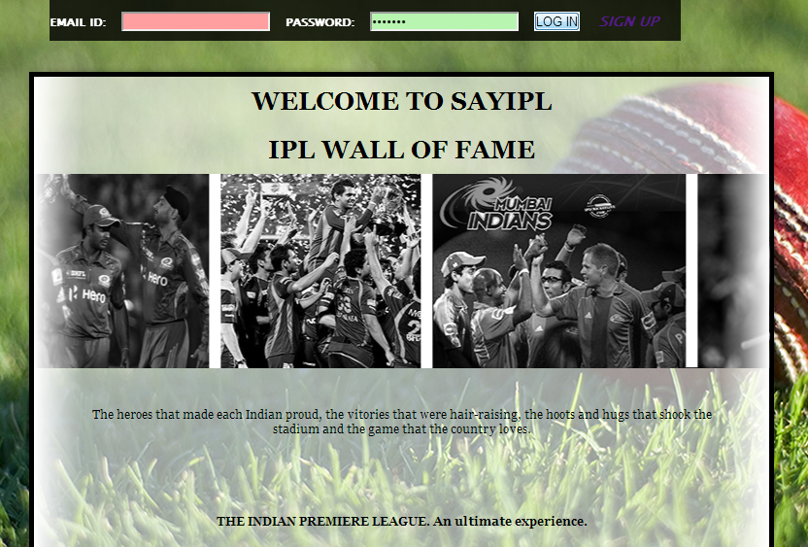

* + 1. When a user does not enter a password

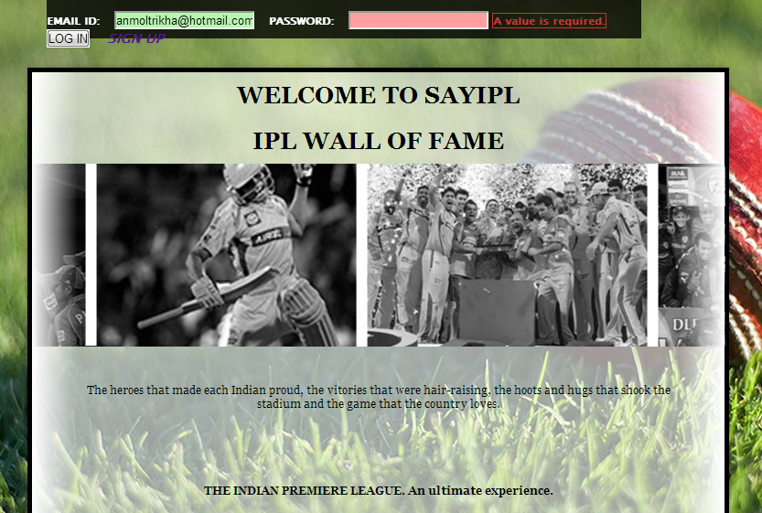

* + 1. When a user does not enter fields while signing up

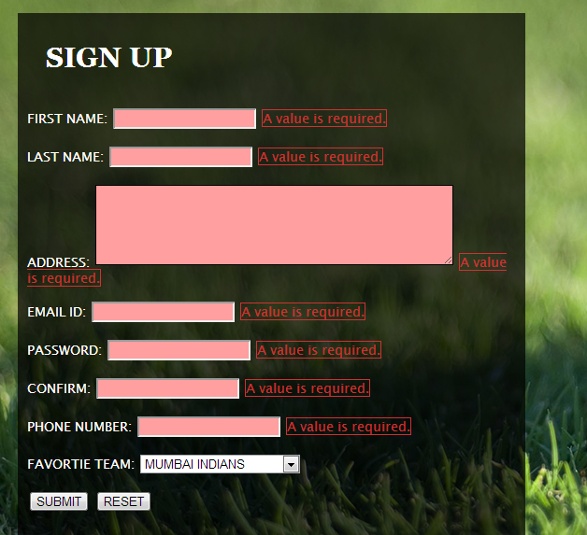

FUTURE SCOPE

* We are planning to develop a mobile application of the website.
* Both the channels (Set Max and Sony Six ) will be provided as an option to the user.
* Planning to add more teams.
* More Products to be added to the shopping cart.

Bibliography

During the development of this project, we have referred to the following sources.

* [www.lynda.com](http://www.lynda.com)
* [www.google.com](http://www.google.com)
* [www.iplt20.com](http://www.iplt20.com)
* [www.mi.com](http://www.mi.com)
* [www.rcb.com](http://www.rcb.com)